**Practical 8**

1. **Nearest Neighbor Analysis**

GIS is very useful in analyzing spatial relationship between features. One such analysis is finding out which features are closet to a given feature. QGIS has a tool called Distance Matrix which helps with such analysis.

Step 1:

Go to layer tab – Add layer – Add vector layer

Select vector dataset as -ne_10m_populated_places_simple.shp click on add.

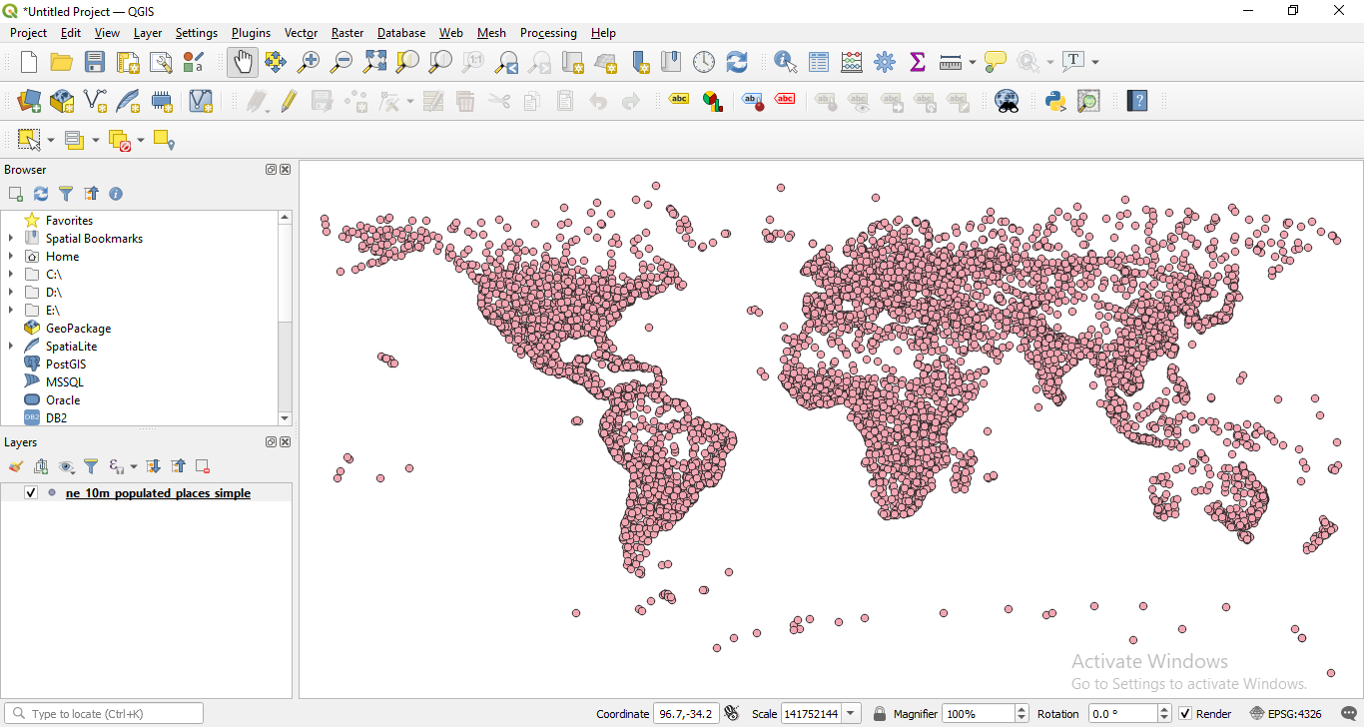

Step 2:

Go to layer tab – Add layer – Add delimited text layer

Select vector dataset as -earthquakedatabase1.tsv file click on add.

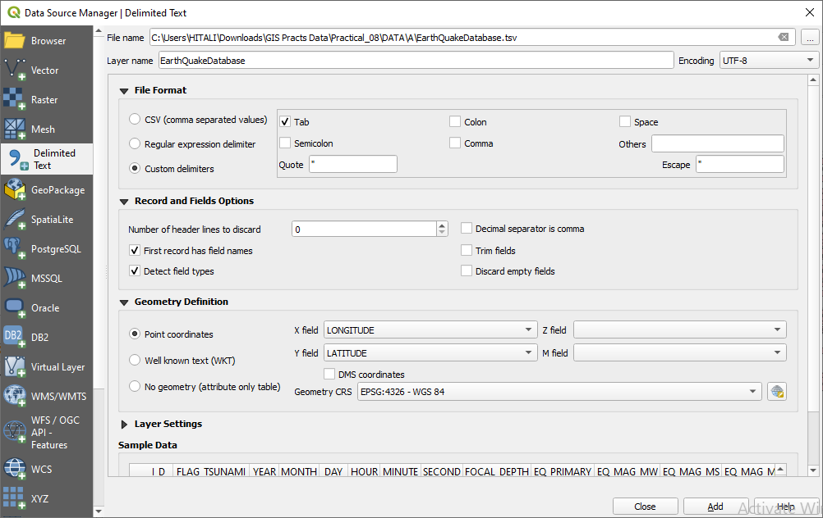

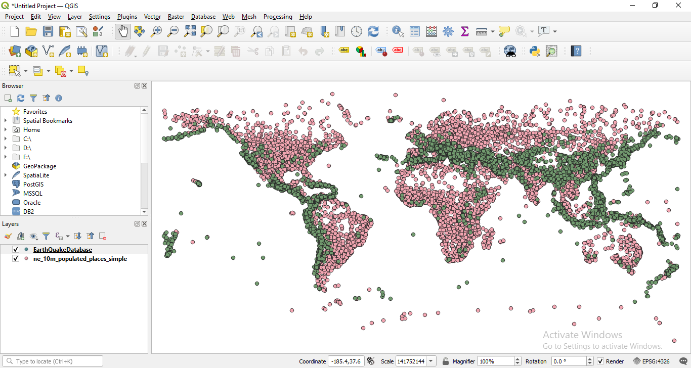

Step 3:

Right click on earthquakedatabase – click on open attribute table you will see some null values

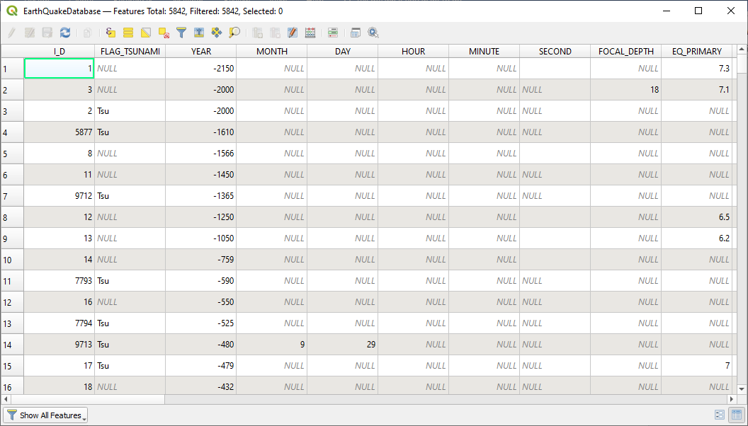

Step 4: Go to processing tab – toolbox – vector geometry – select remove null geometrics. Select the option also remove empty geometrics click on run.

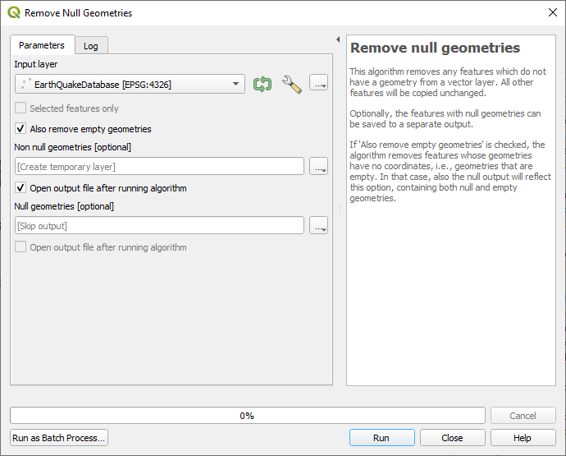

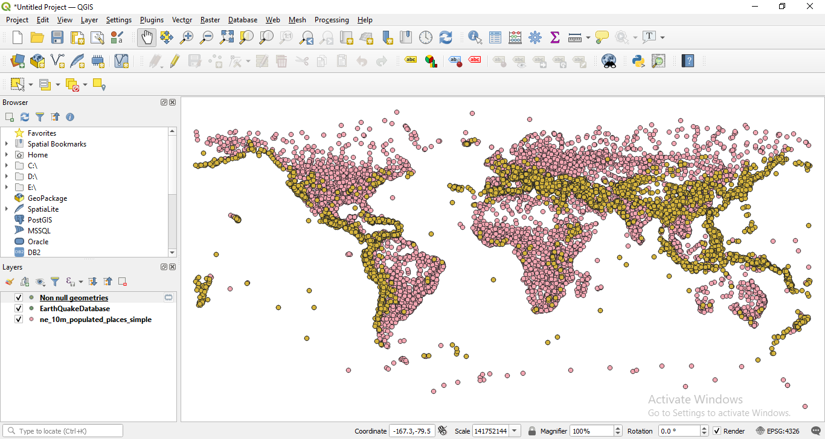

Step 5:

Go to processing tab – toolbox – vector analysis – Distance to Nearest Hub (Line to Hub)

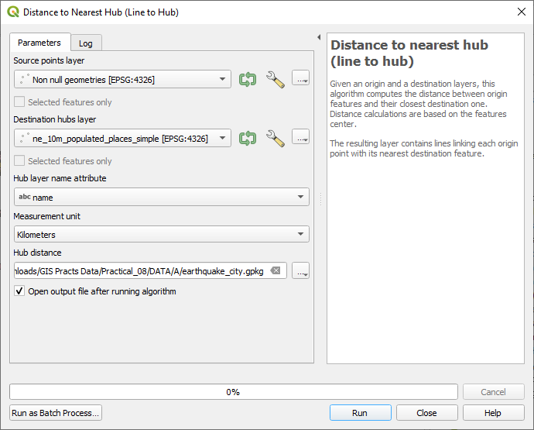

Output:

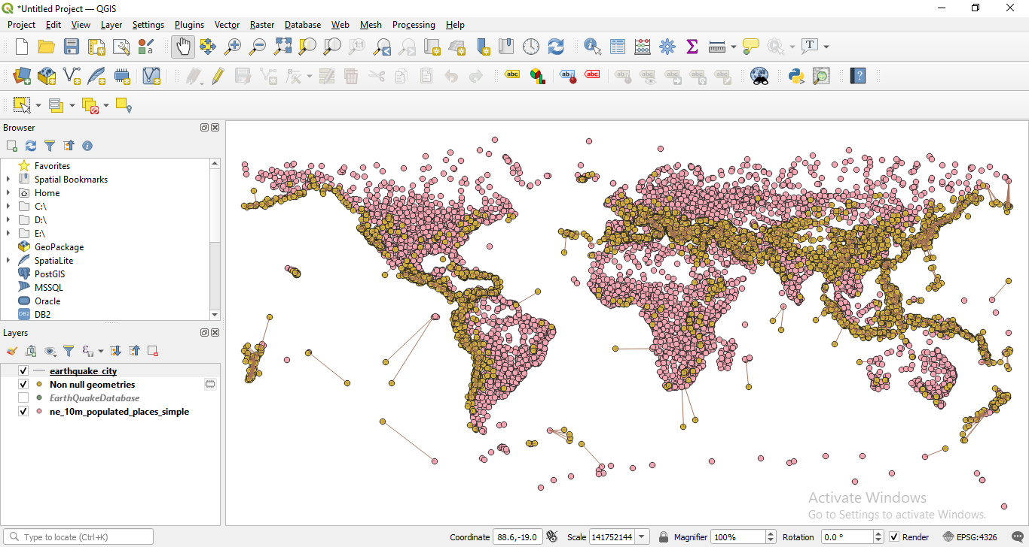

1. **Sampling raster data using points and polygon**

Step 1:

Go to layer tab – add layer – add raster layer

In the data sets select this image - us.tmax_nohads_ll_20140525_float click on add.

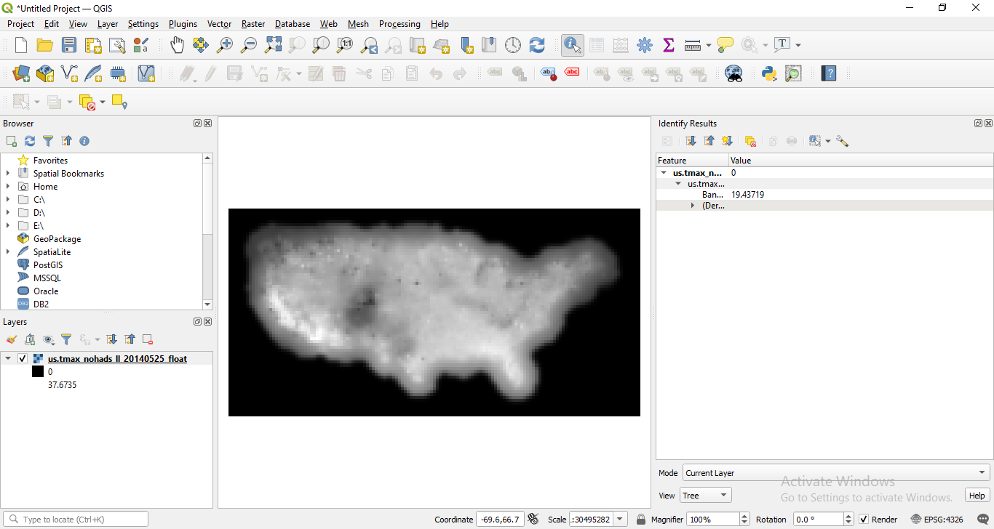

Step 2:

Go to layer tab – add layer – add delimited text layer

In the data sets select - 2013_Gaz_ua_national click on add.

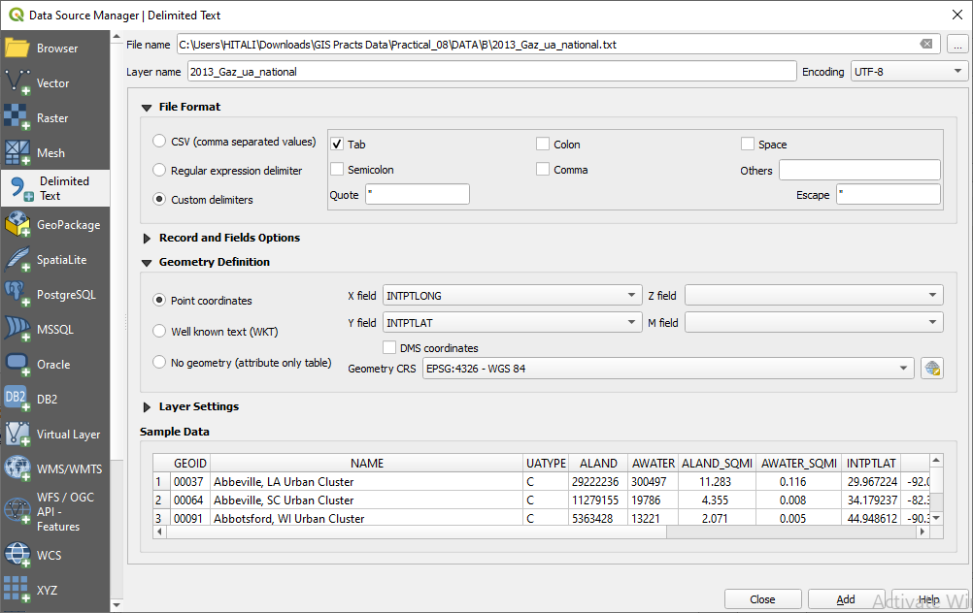

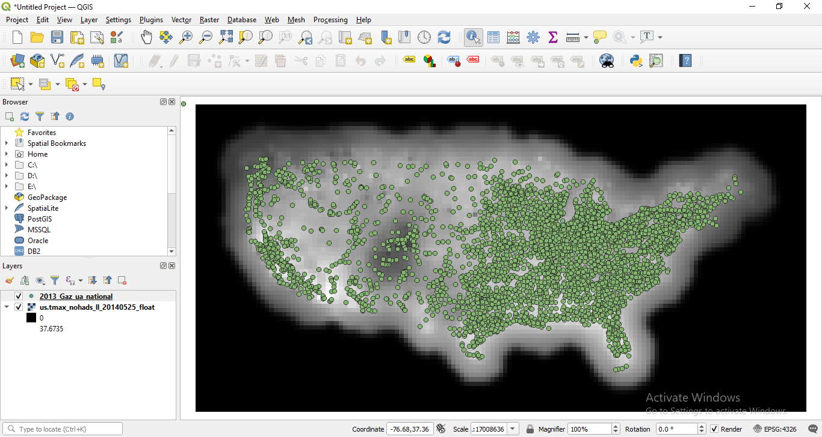

Step 3:

Go to processing tab – toolbox – raster analysis – double click on sample raster values.

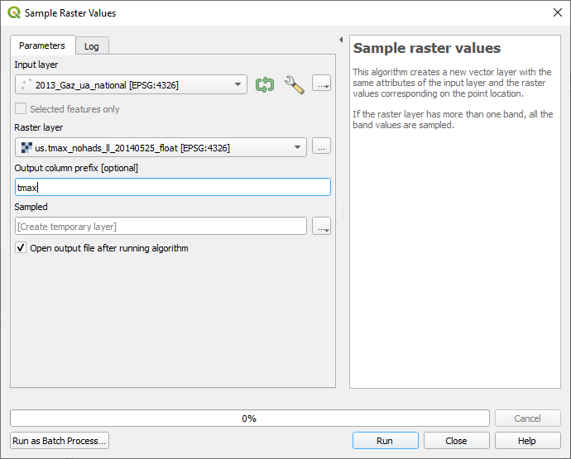

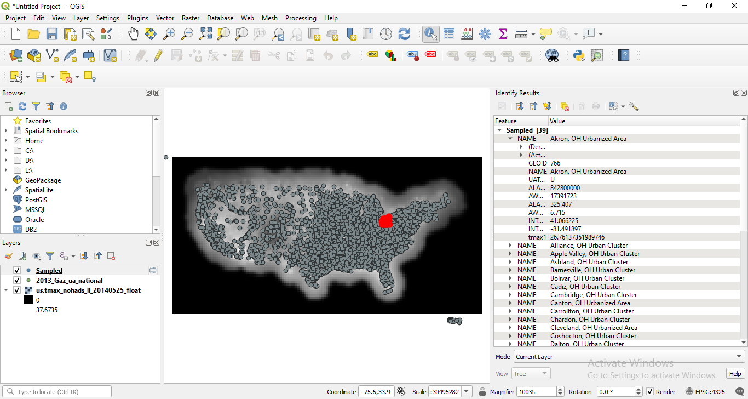

Now for doing sampling data using polygon remove the sampled and 2013 us national layer.

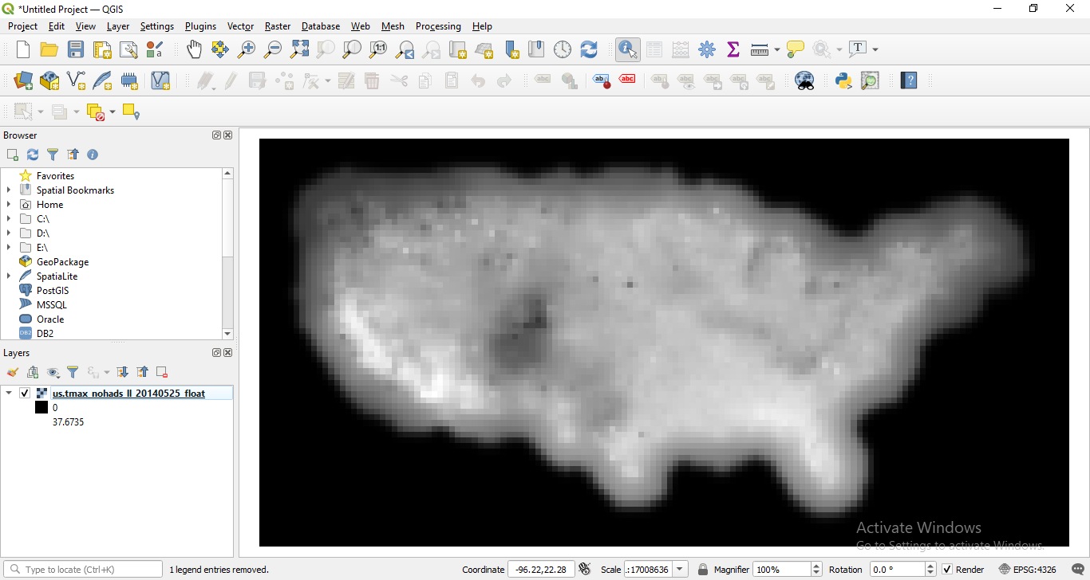

Step 4:

Go to layer tab – add layer – add vector layer

In the data sets select tl_2018_us_county.shp click on add.

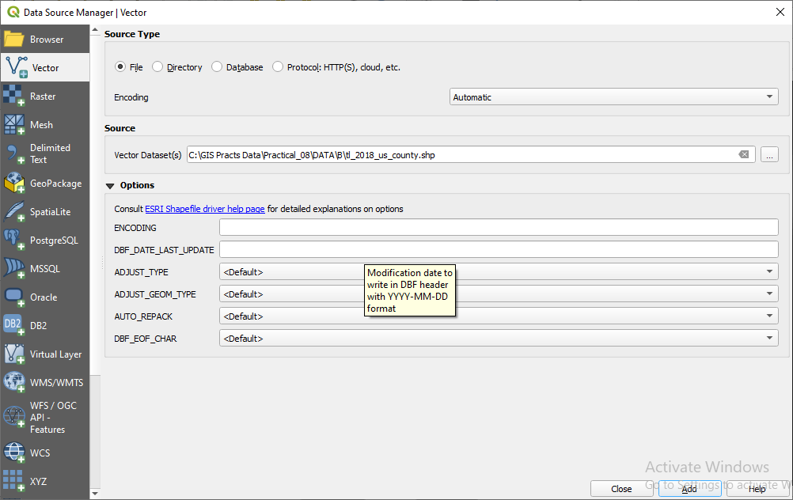

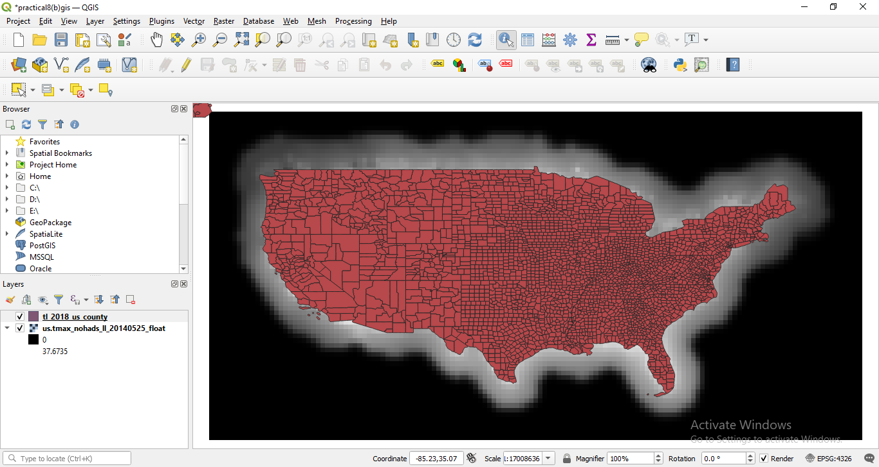

Step 5: Go to processing – toolbox – zonal statistics (search)

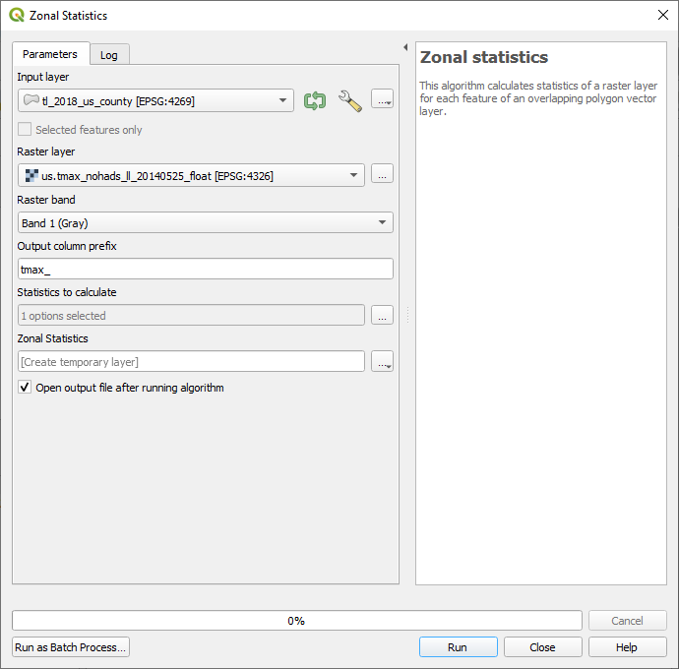

Click on statistics three dots and select only mean value and then run.

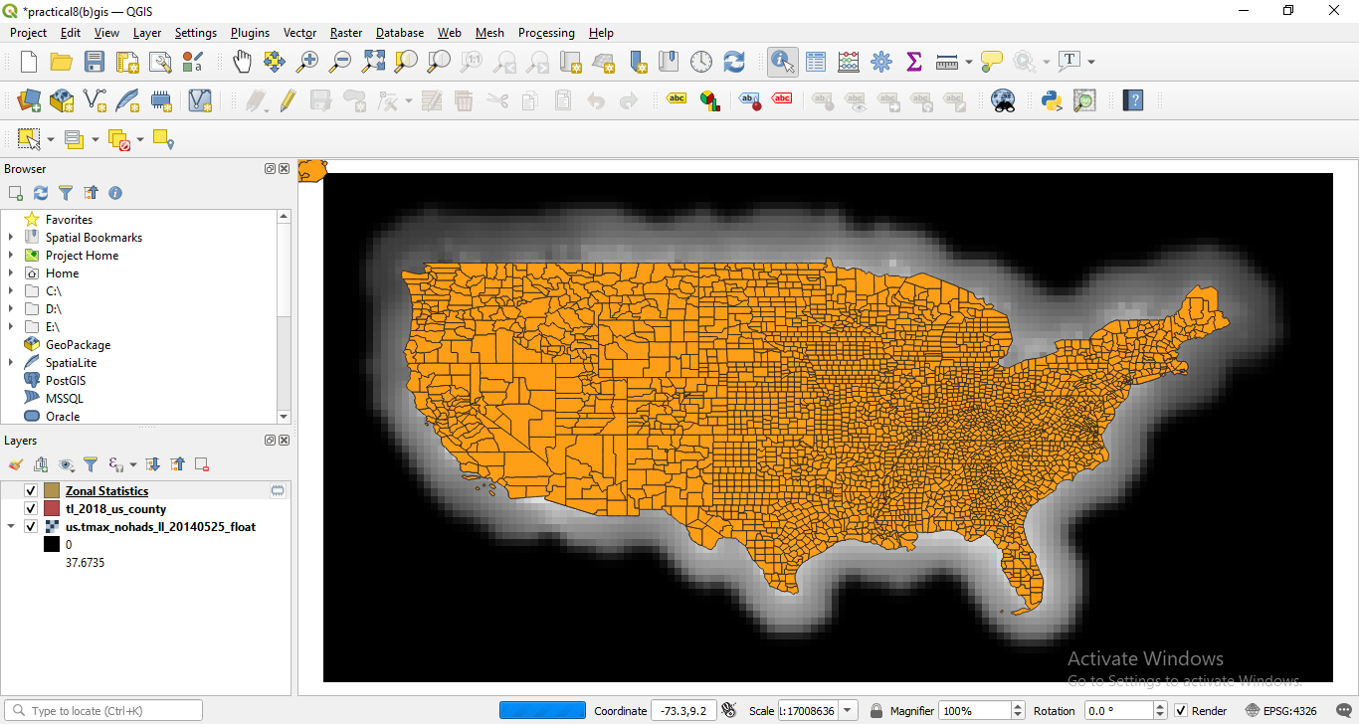

Go to properties there will be new column mean is added into the attribute table.

Output:

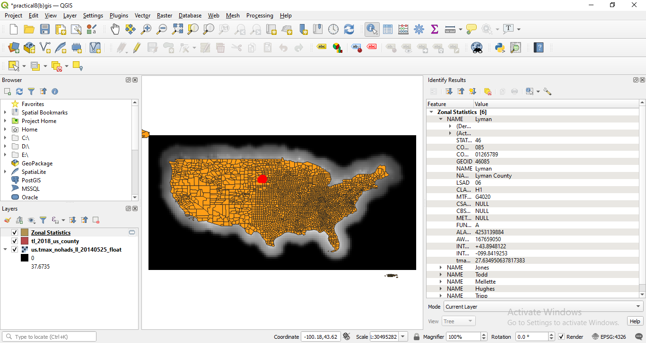

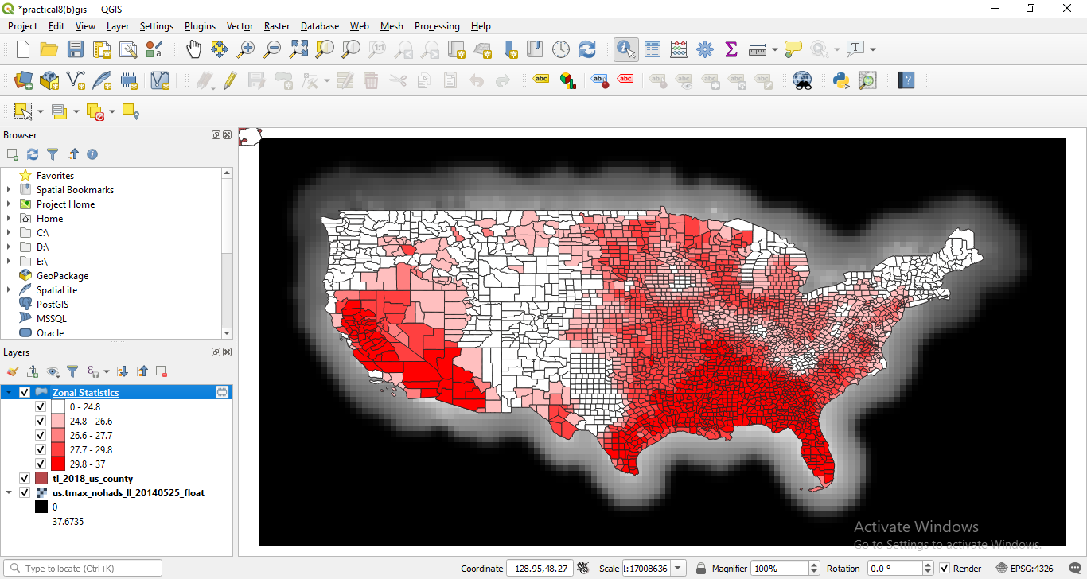

1. **Interpolating Point Data**

Interpolation is a commonly used GIS technique to create a continuous surface from discrete points. In QGIS, interpolation is achieved using the built-in interpolation tools from the processing toolbox.

Step 1:

Go to layer tab – add layer – add vector layer

In the data sets select - Arlington_Surroundings_2007_stpl83 click on add.

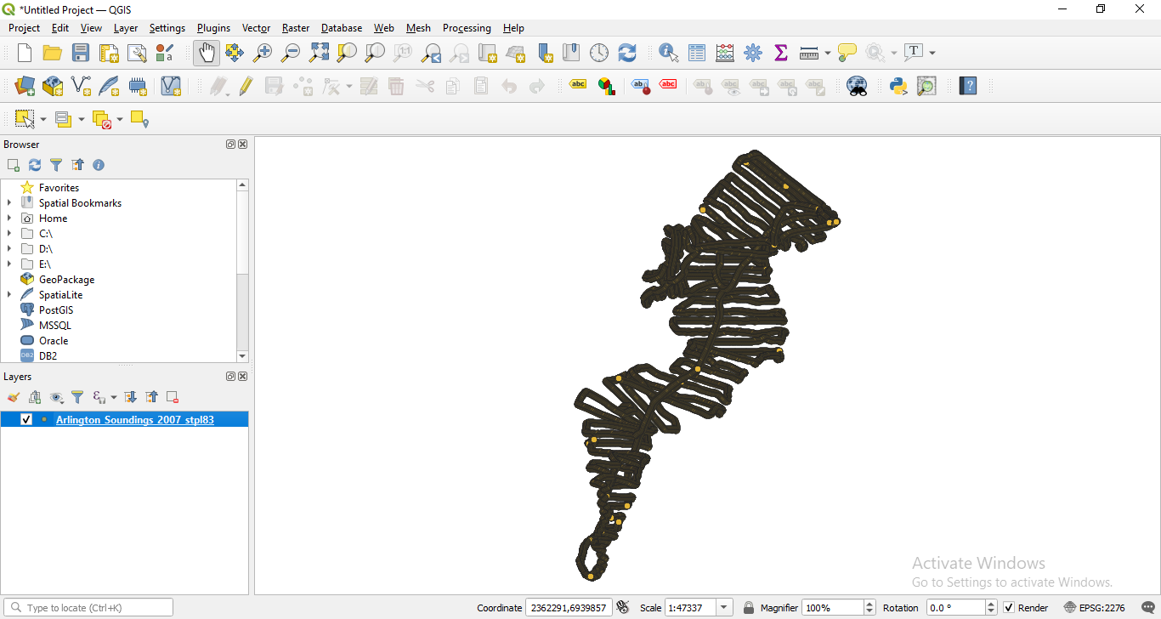

Step 2: Go to layer tab – add layer – add vector layer

In the data sets select - Boundary2004_550_stpl83.shp click on add.

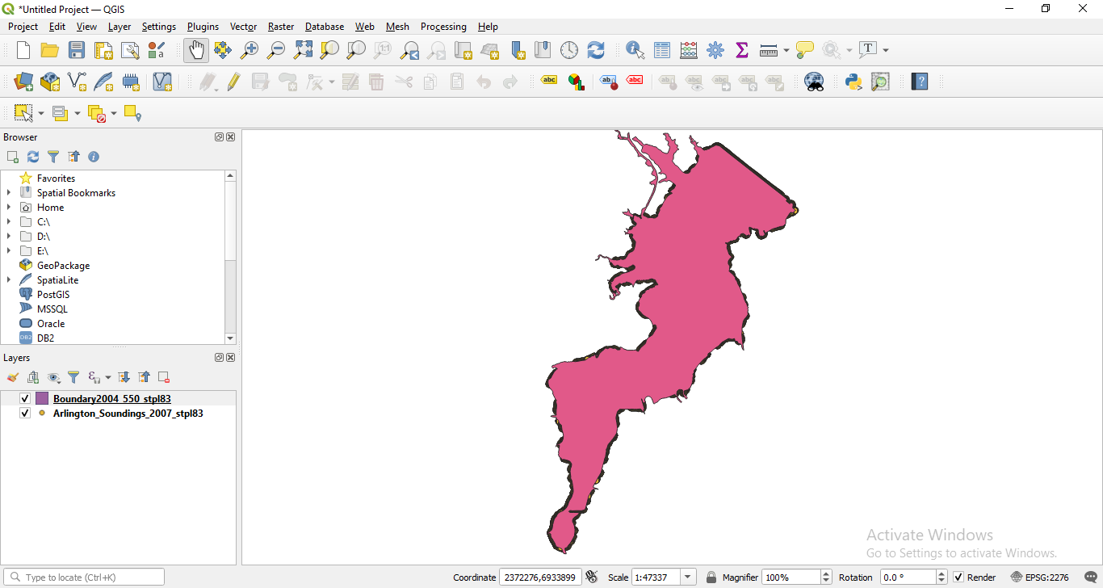

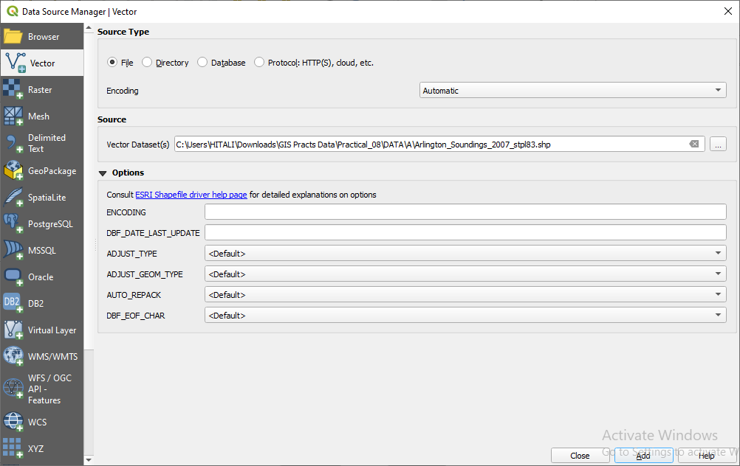

Step 3: Go to layer tab – add layer – add vector layer

In the data sets select - Islands_2004_550_stpl83.shp click on add.

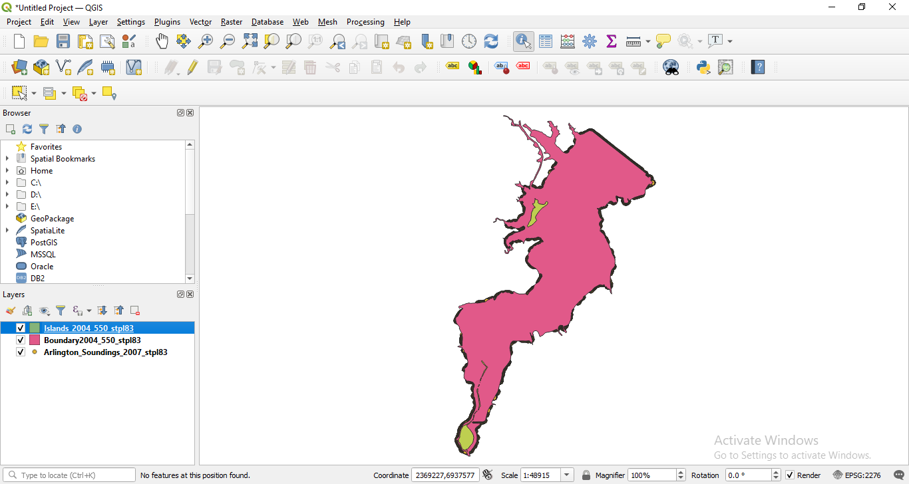

Step 4: Go to processing tab – toolbox – interpolation (search) – TIN interpolation

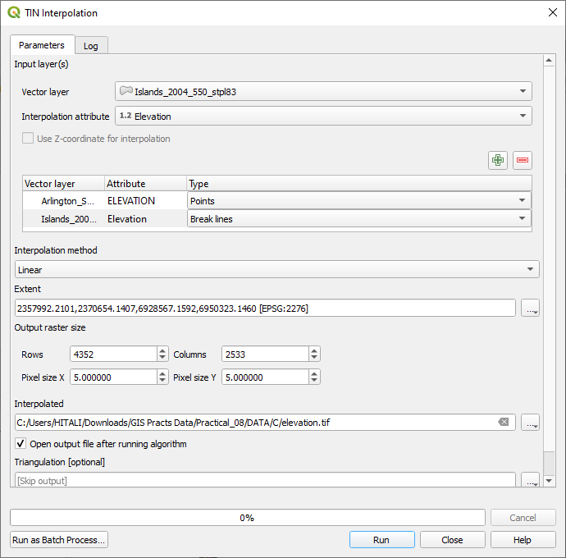

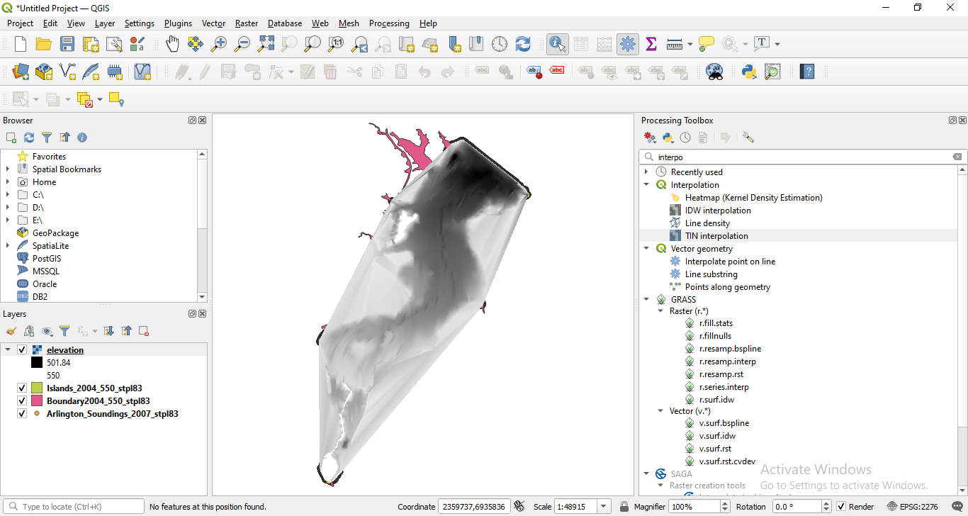

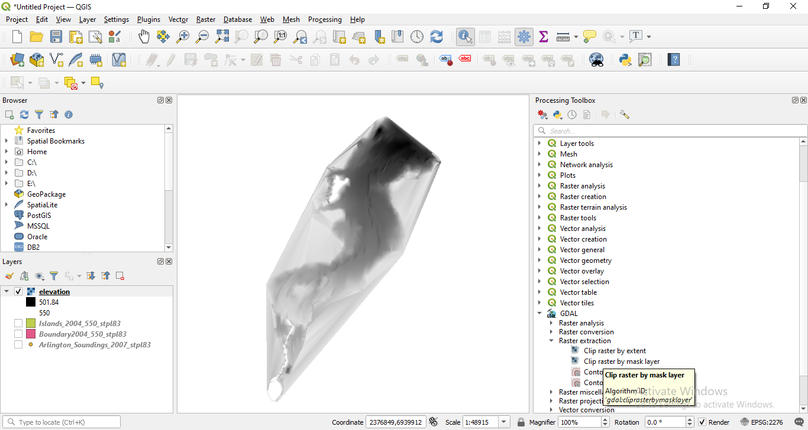

Step 5: Go to processing – toolbox – GDAL – raster extraction – clip raster may mask layer.

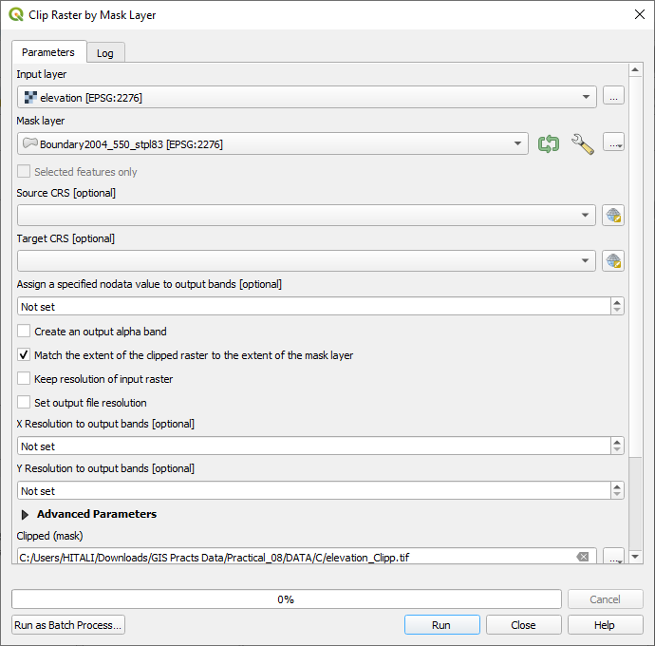

Right click on clip and then go to symbology.

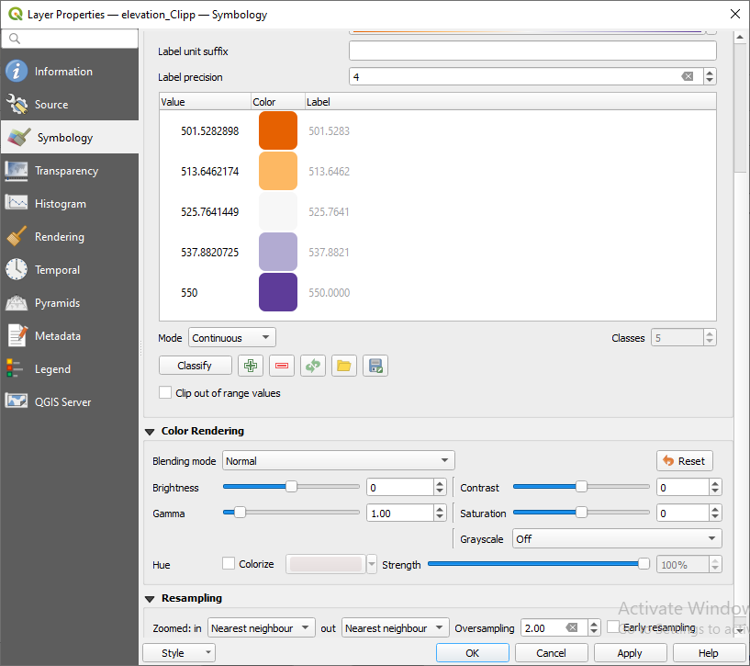

Click on classify and then ok.

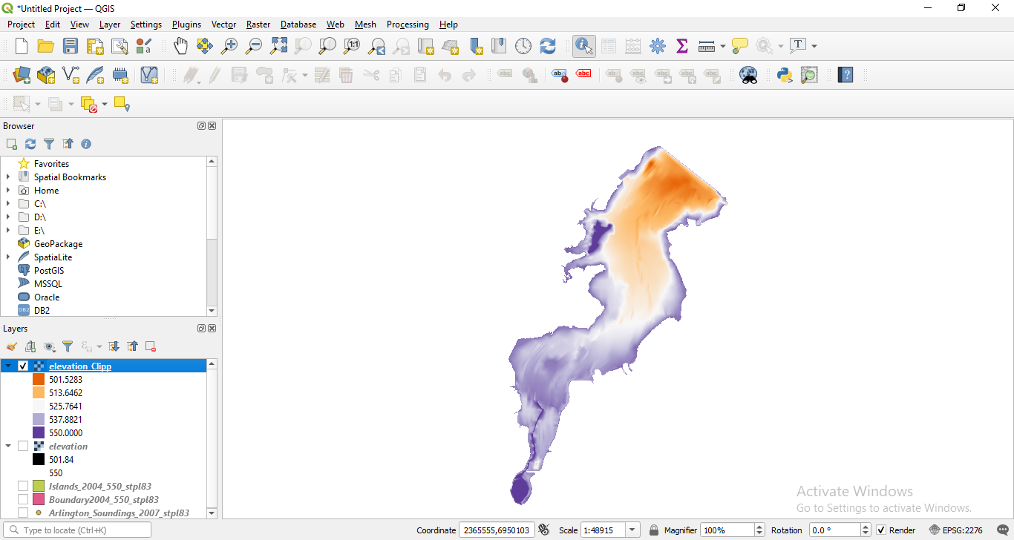

Step 6: In the processing -toolbox -GDAL – raster extraction- select contour

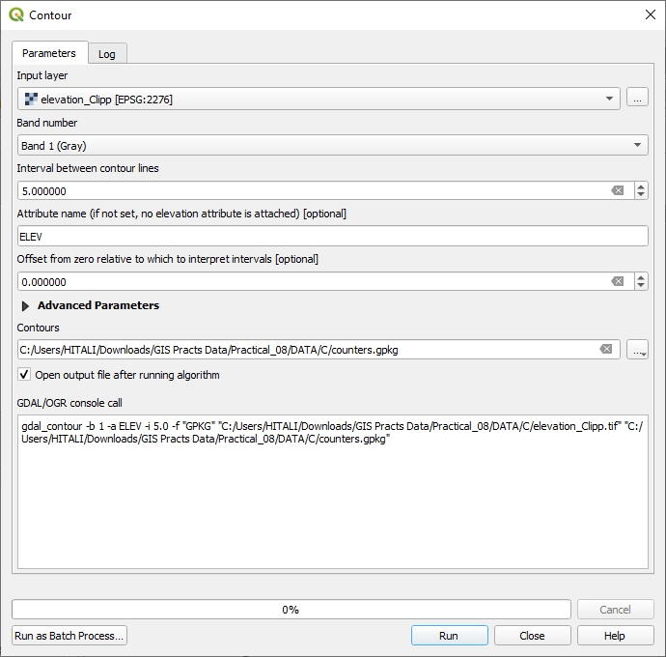

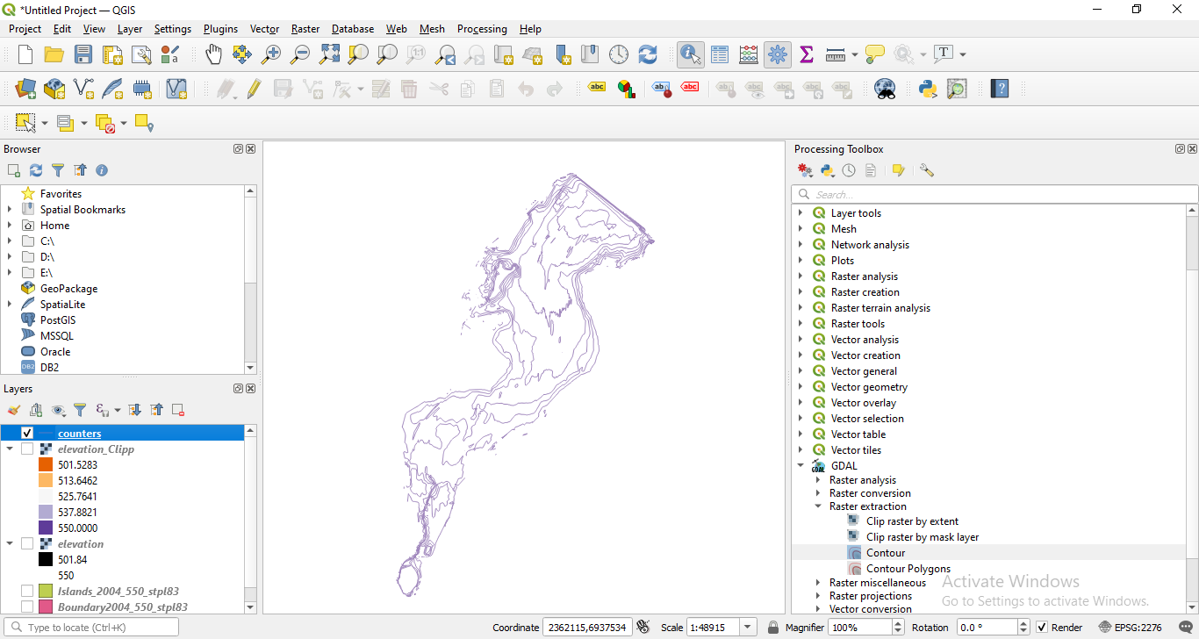

Go to the properties of contour

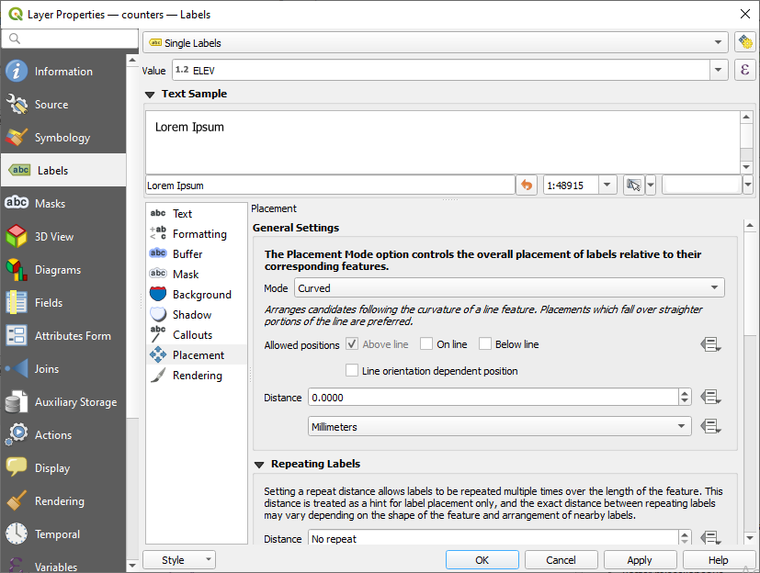

Output:

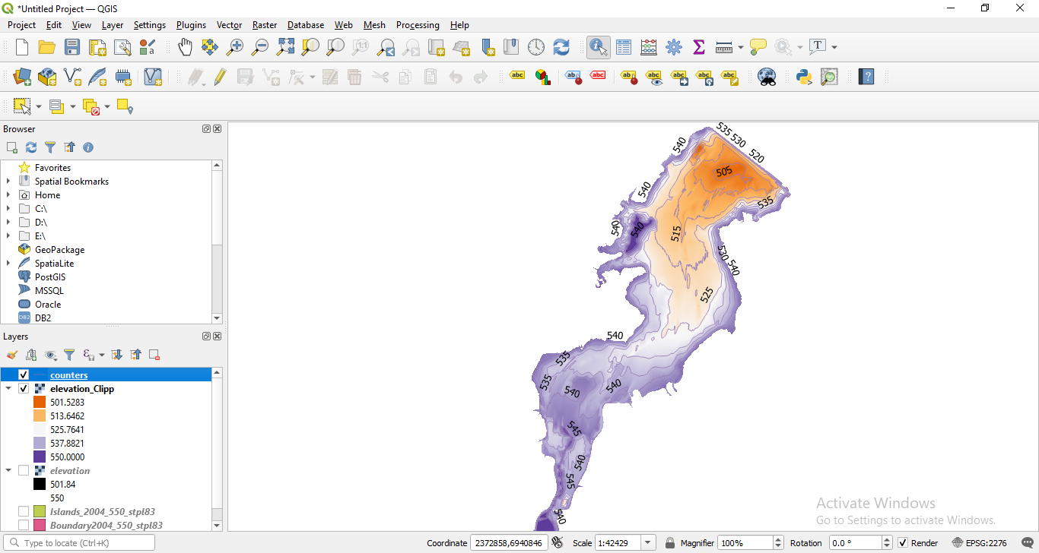

**Practical 8**

**Validating map data.**

Step 1: Open Kenya_epidemicological_data.xls in excel. Go to view tab, click freeze panes and choose freeze top row.

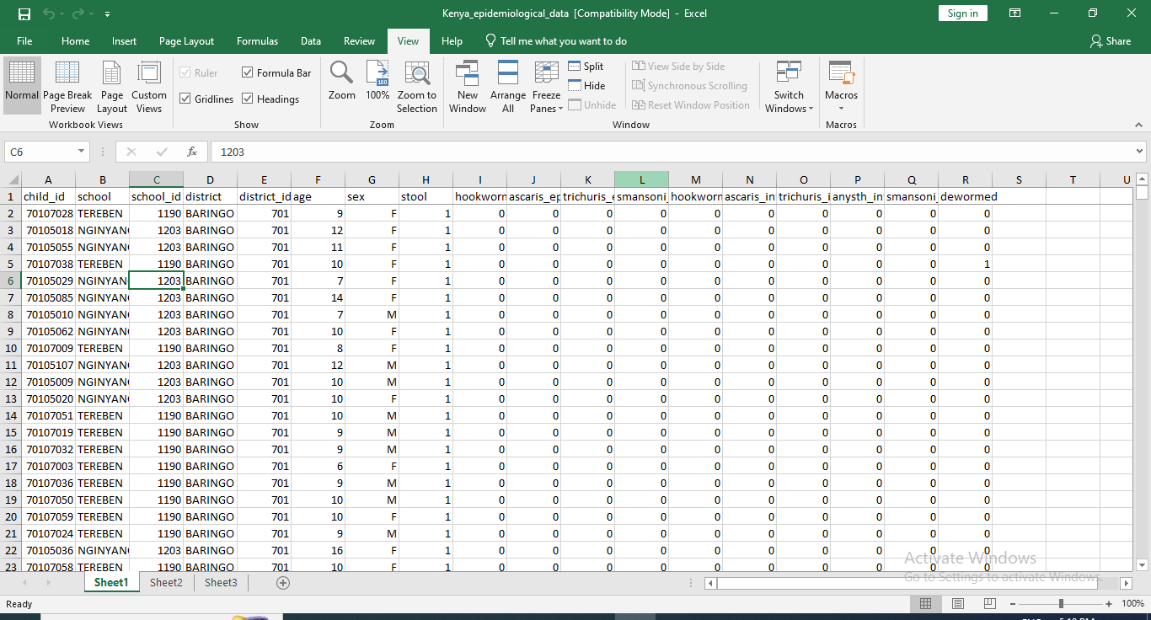

Step 2: Select the entire “child_id” column. Under home tab, click on conditional formatting – highlight cell rules – select duplicate values.

Now select the first combo box and select Duplicate and select Light red fill with Dark red text in the next combo box.

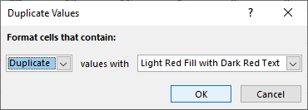

Step 3: Removing Duplicates Select all the columns of existing worksheet Now go to Data Tab and select Remove Duplicates

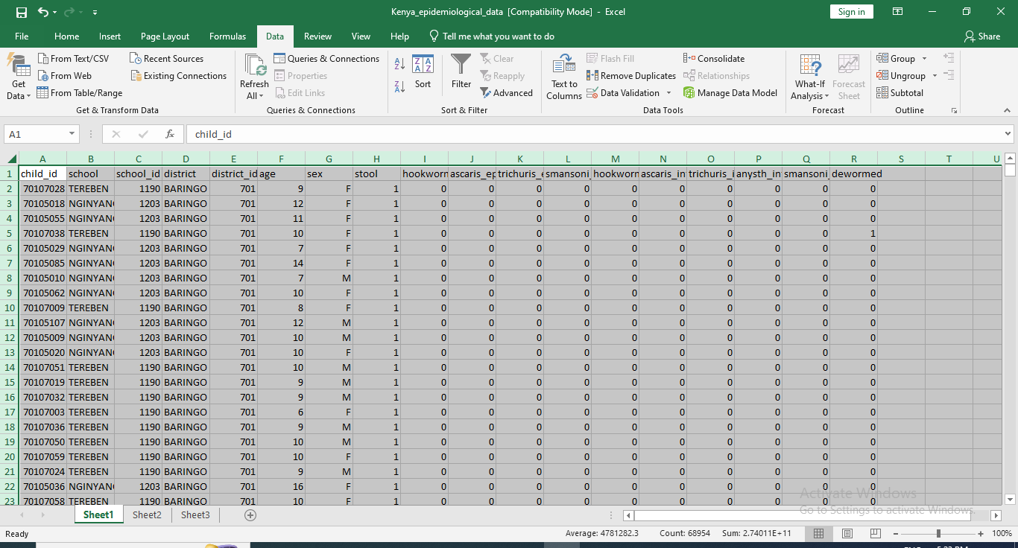

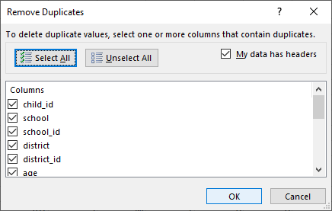

Step 4: Coding of variables In the current worksheet, select the sex column. Now type Ctrl+F and use Replace Function and Replace as follows

M-1 and F-2 Please keep track of how many values are getting replace.

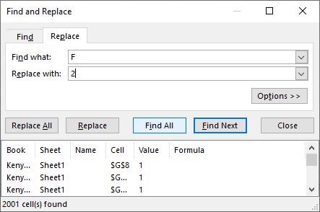

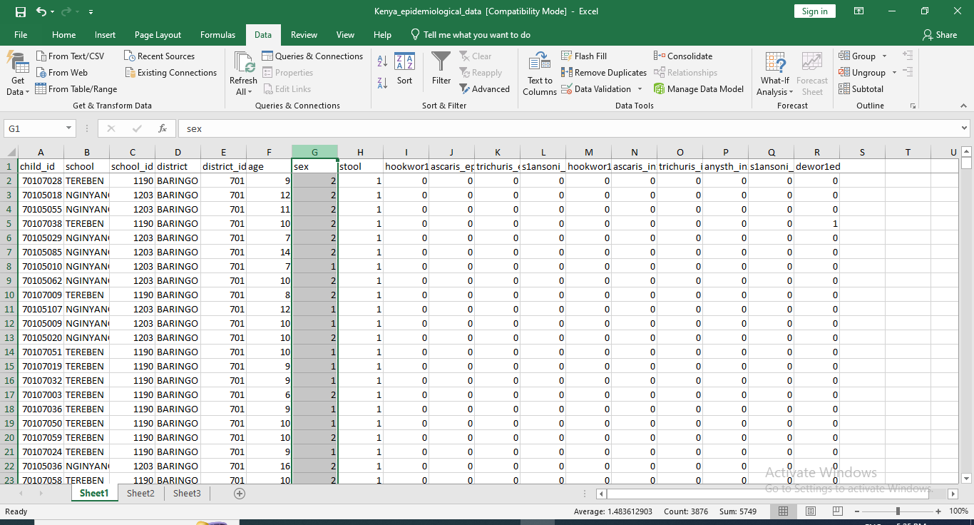

Step 5: Verifying the plausibility of data

In this step, we perform two basic operations

A. Coding of variables

B. Using a filter to detect outliners

A) Coding of variables Select the age column in the existing worksheet. Now go to Insert tab and select Scatter.

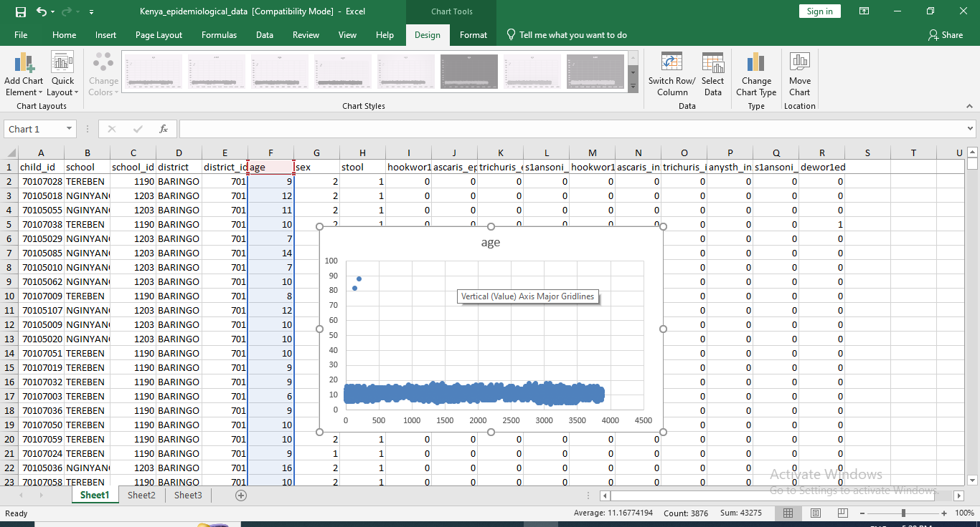

b) Using a filter to detect outliners

First go to the Home Tab>Sort and Filter>Filter. Click and apply the filter to all the columns of the worksheet.

Now click on age filter and click on Number Filter> Greater Than option and type the value 20 in greater than field.

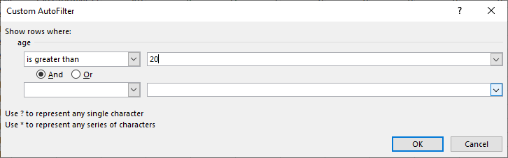

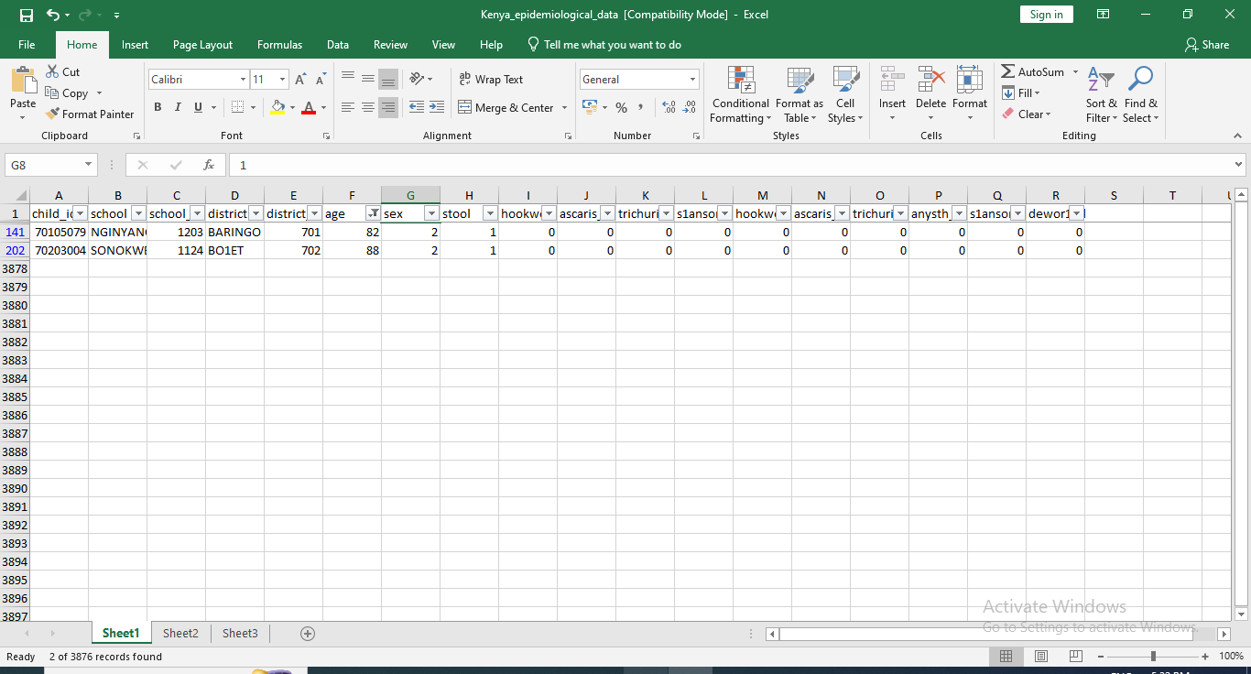

Step 6: Logical Data checks In this step, we perform two basic operations

A. Cross Tabulations

B. Formulas

1. Cross Tabulations Open the existing worksheet. Now go to Insert Tab and select Pivot table function.

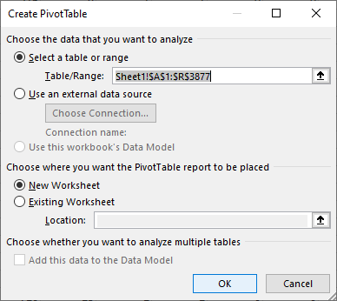

An empty table is inserted in a new sheet and a window will open on the right hand side named PIVOT TABLE FIELD LIST.

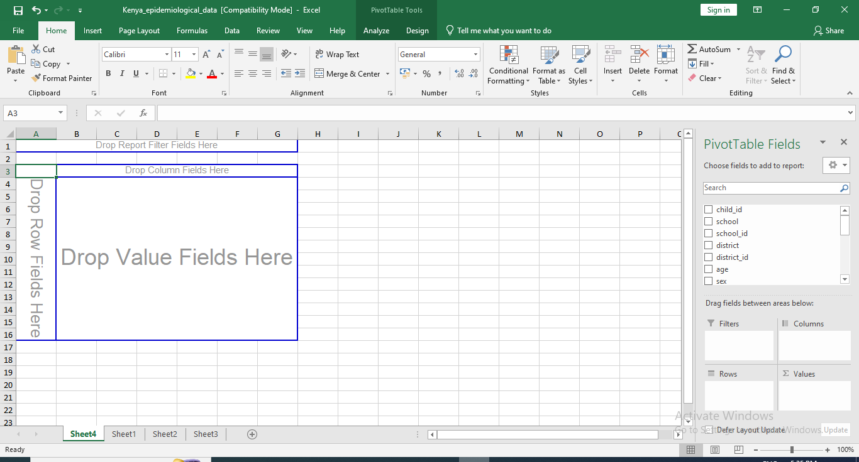

From the PivotTable Field List, drag the “stool” item and drop it into the “Row Label” field as show above.

Similarly, Click on anysth_inf and draw it into the “Column labels” and “Σ Values” field. To include the count of observations in the table you might need to change the value field settings to count.

Click on the combo box Sum of stools and Click on Value Field Settings. Change the value in Summarize value filed by to Count and click OK. Table is updated with count values as shown below

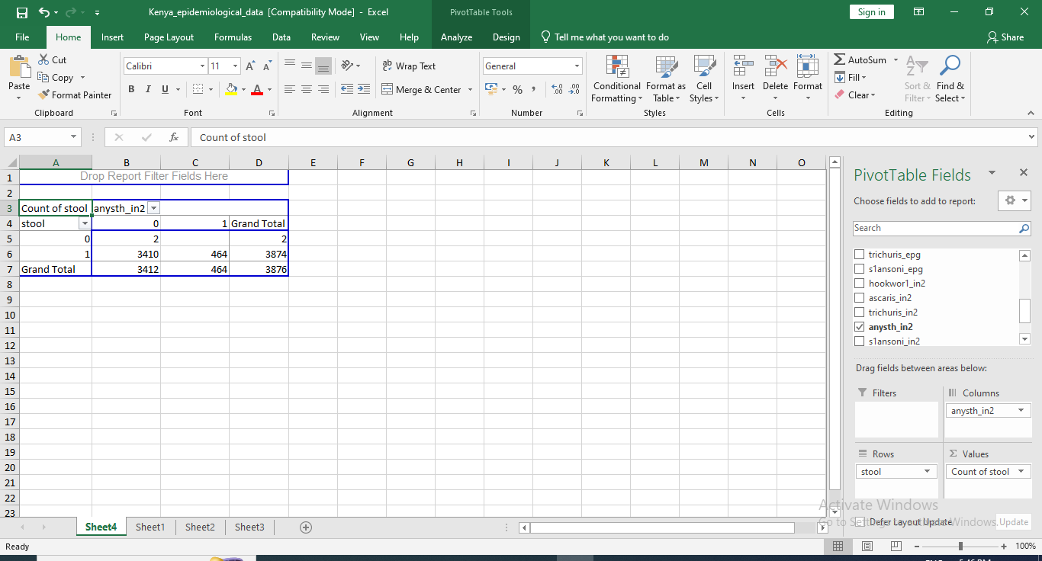

1. Formulas Open the existing worksheet Create a new column with the variable called check Type the following formula in S2 column of worksheet =IF(AND(H2=0, NOT(P2="")),1,0)b)

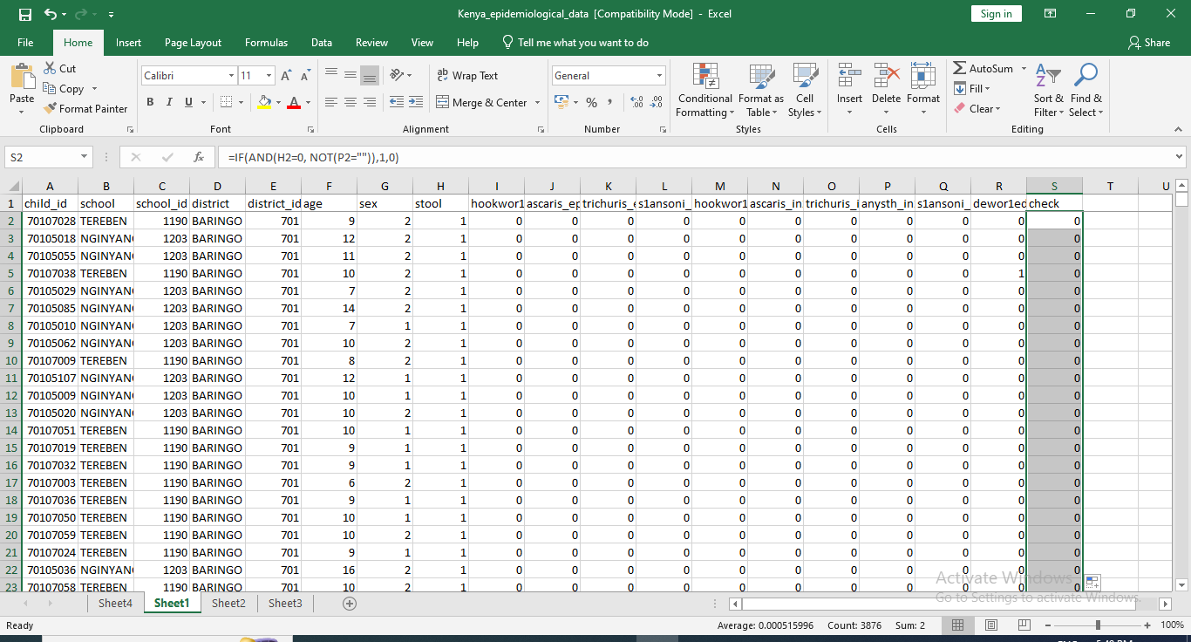

Step 7: Verifying the coordinates of mapping data.

Create a New Project - Navigate to Add Vector Layer and add file: Kenya_admin.shp

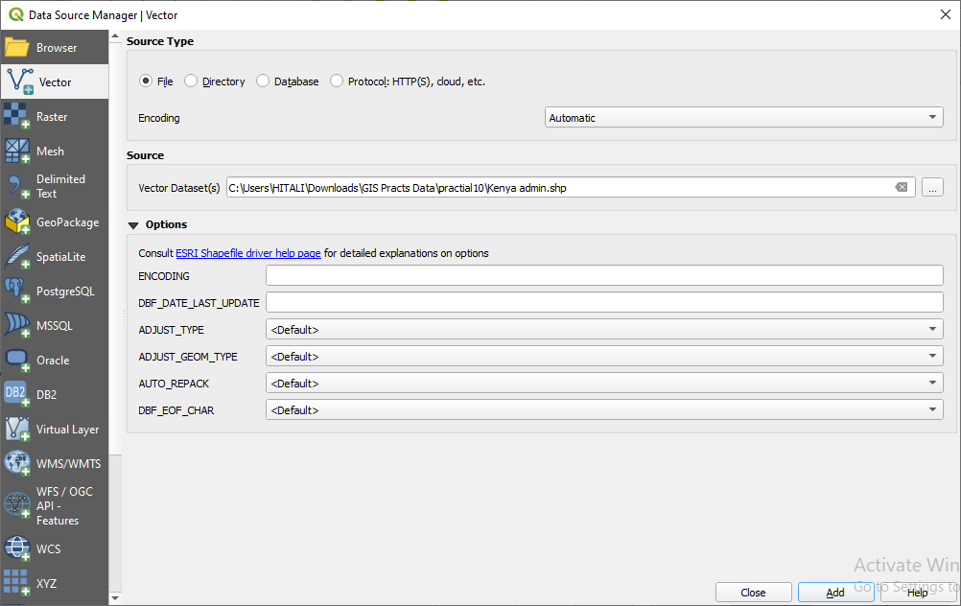

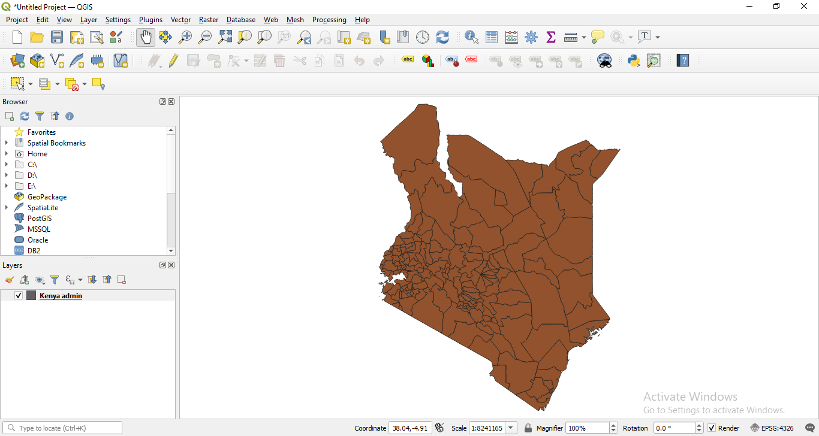

Step 8: Similarly, navigate to Add Delimited Text Layer. Here we have to add file: Kenya_school_location.csv. In the Geometry Definition section, there is a field called Geometry CRS, in that we have to select WGS84 as coordinate system.

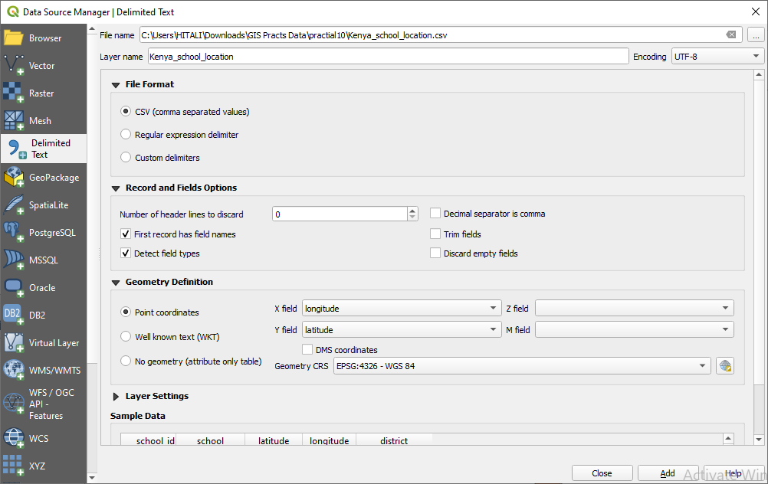

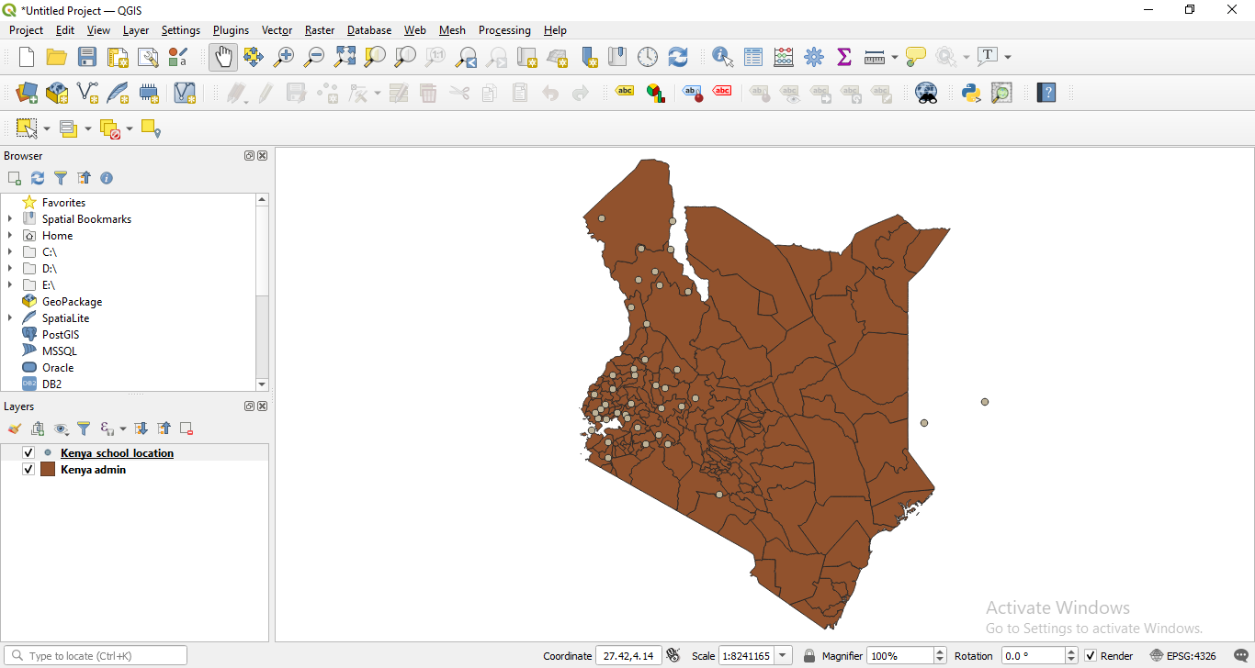

Step 9:

Two points are not on the map. To examine this, we need to save these layers as a Shapefile, to do that select both the layers Kenya_school_location and Kenya admin, then right click on them and choose Save Features As..

In the menu that comes up, set Format as ESRI Shapefile and put File Name as Kenya_schools.shp After this is done you can uncheck the Kenya_school_location in the layers section.

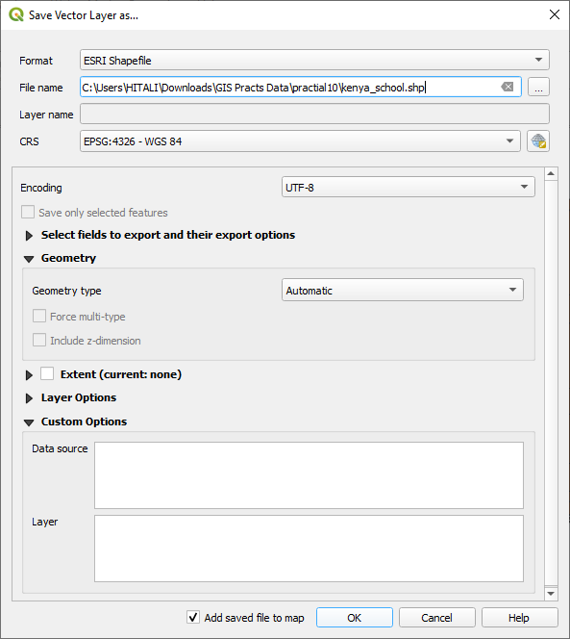

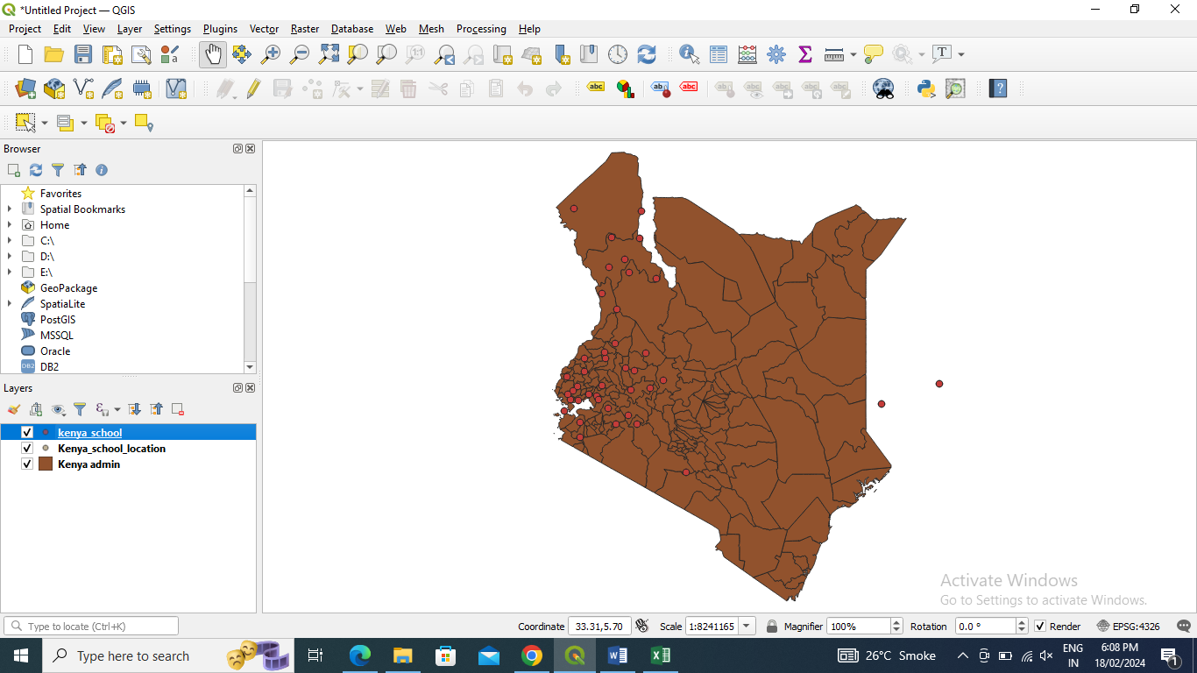

Step 10: Details of these 2 points that are not on the map, select the Kenya_schools layer, click on the Identify Features Tool button and then click on the points outside of Kenya to get their details.

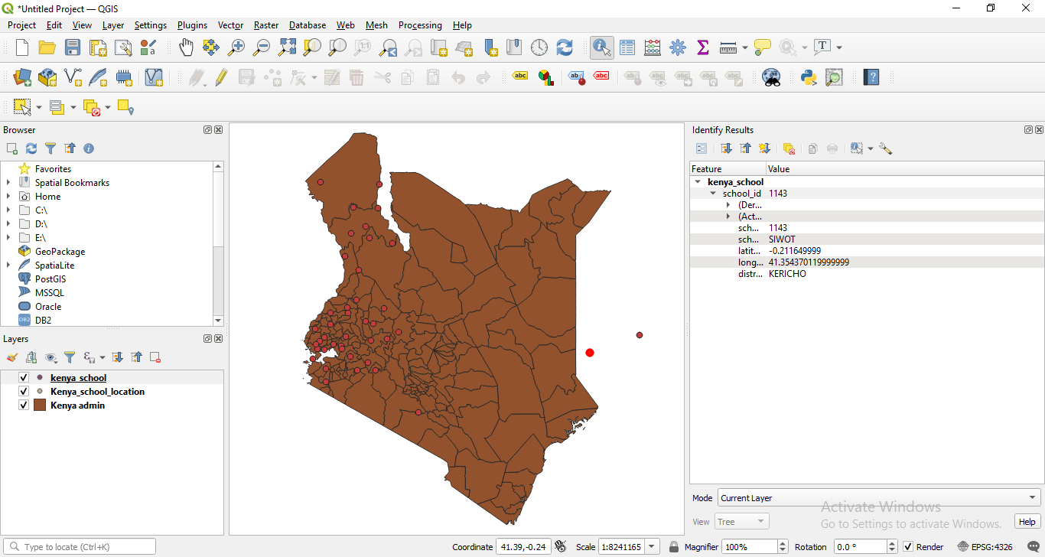

Step 11: we want to add the district information to the map. Therefore, we will join information based on the geographical localization. In the menu click on Vector, then Data Management Tools, then select Join attributes by location.

Then select Kenya_schools as Input layer and Kenya_admin as Join layer

We also need to save the output(Kenya_school_district.csv) so in Joined Layer, click “…”button to Browse location.

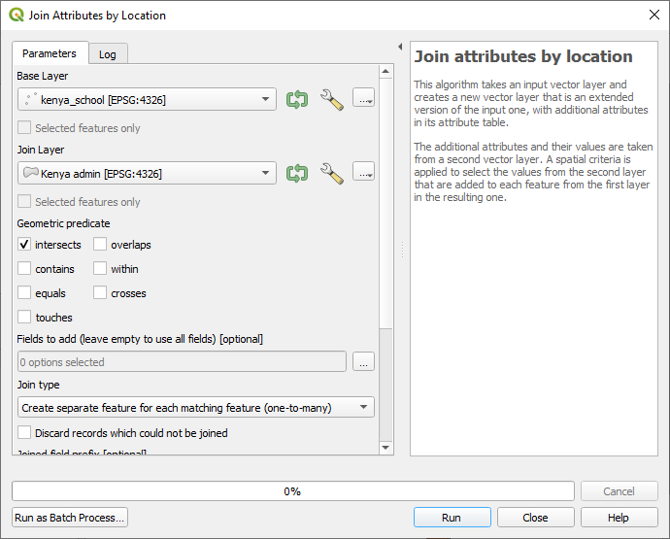

If it not runs. Use the skip ignore feature for both.

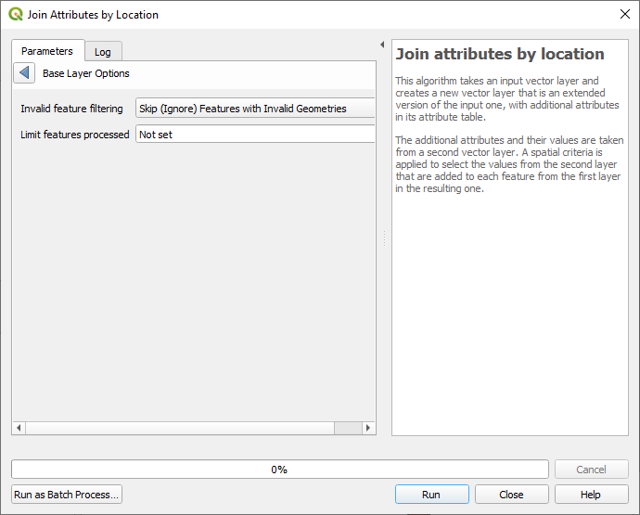

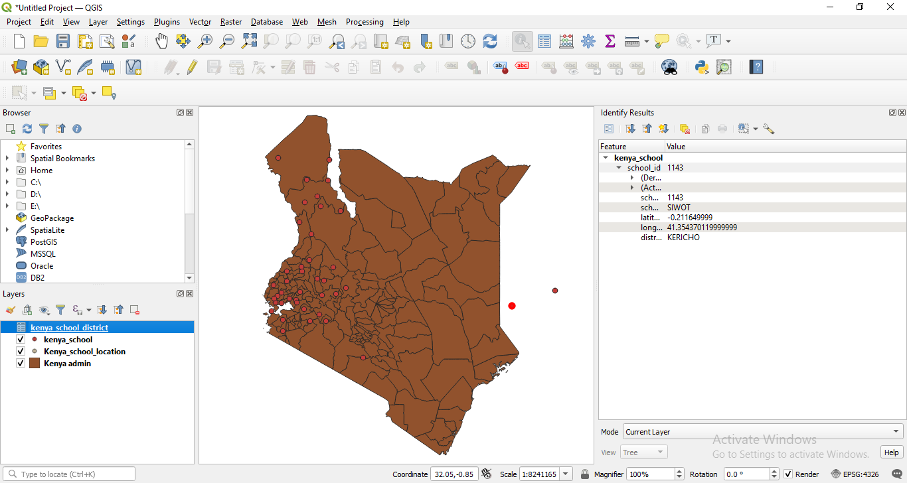

Step 12: Navigate to the location of saved file Kenya_school_district.csvand open it, you should now be able to compare both district and Name for discrepancies.

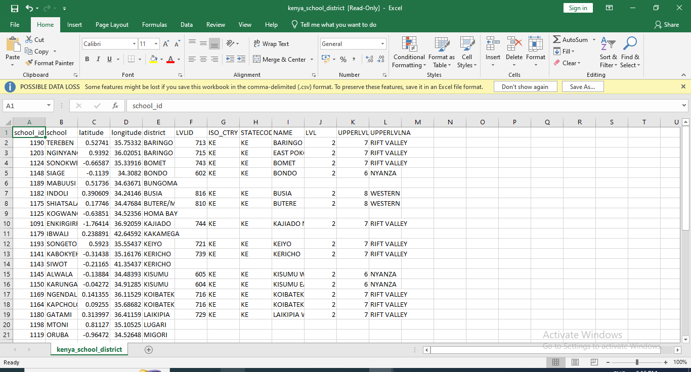

Step 13: We need to change the co-ordinate of those 2 points which were not on the map.

So, open the file **Kenya_school_location.csv** and make the following changes, set:

IBWALI: Longitude 34.6459198

SIWOT: Longitude 35.35437012

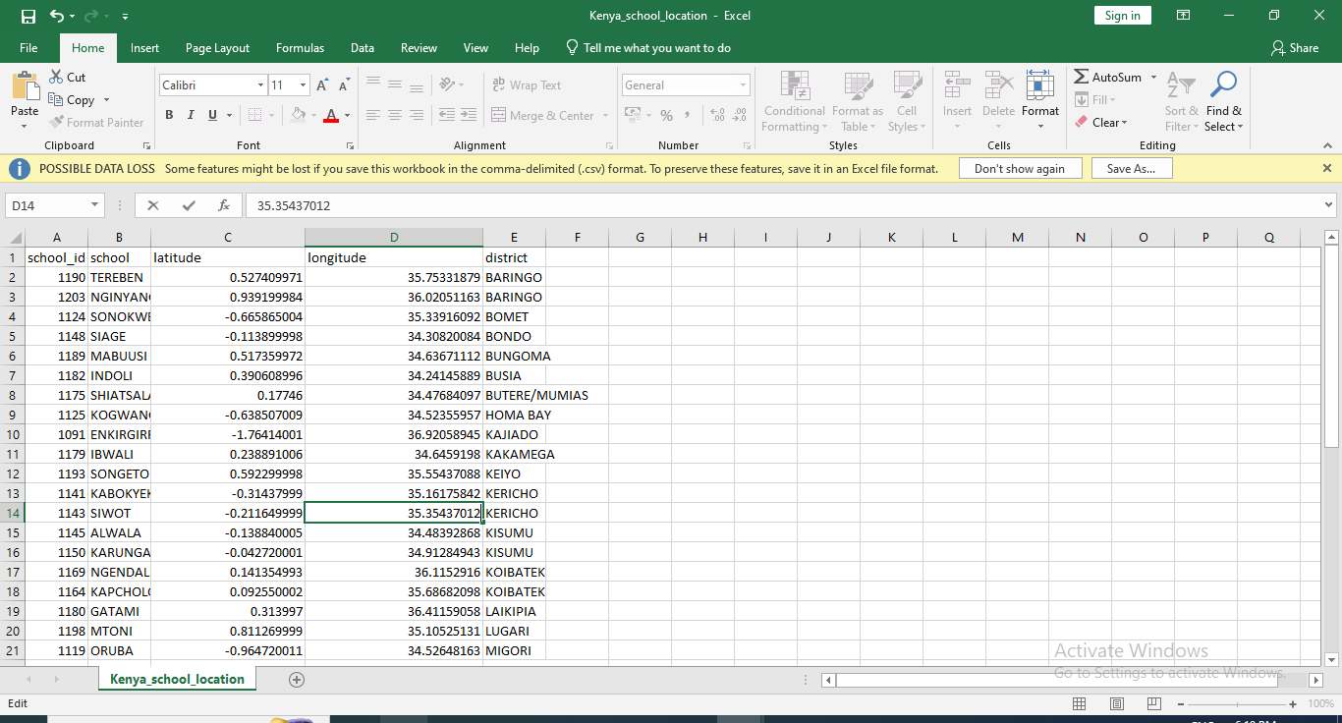

**Save the file as: Kenya_school_location2.csv**

Step 14: Preparing data for mapping Open Kenya_epidemiological_data_2.xls, select the entire sheet, go to Insert tab to create new Pivot Table. Tick New Worksheet to tell Excel that you want to place the table in a new sheet.

Now click on school_idtodragand drop it in the “Row labels” field at the bottom. Add district_id to“Σ Values”and click on it, a drop down list will open, click on Value Field Settings. Choose Average as type of calculation, because all children in the same school will have same district_id.

Now drag and dropchild_id into the “Σ Values” field, click on Value Field Settings and choose Count to summarize the results. So, we come to know how many children per school are infected. Similarly, Drag and dropanysth_inf into the field, click on Value Field Settingsand choose Sum. As, infected is 1 and not affected is 0, the sum will give us the total number of infected children.

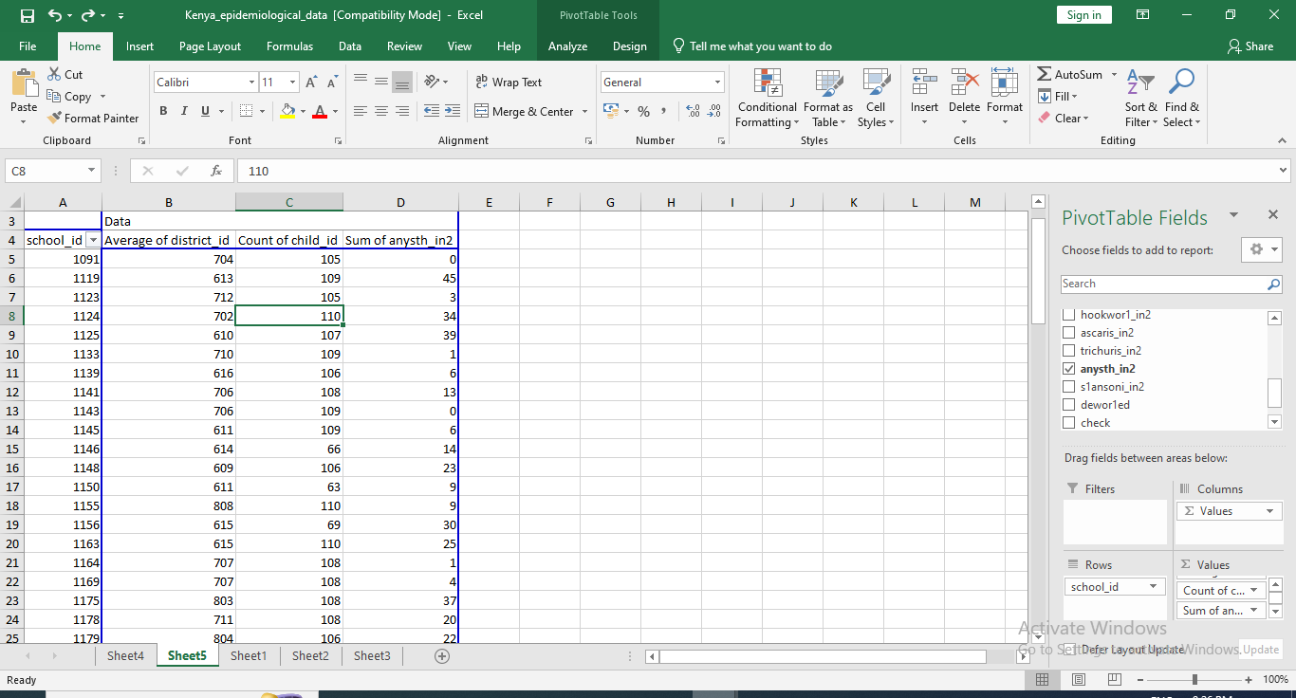

Step 15: Now copy the table, open a new Excel file and paste the values into the new spreadsheet. Therefore, click Paste in the Home tab, then choose Paste special and paste only the values. Remove the last row which has Grand Total and other values.

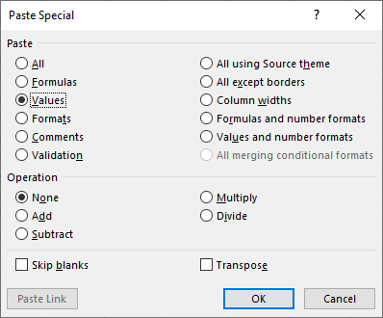

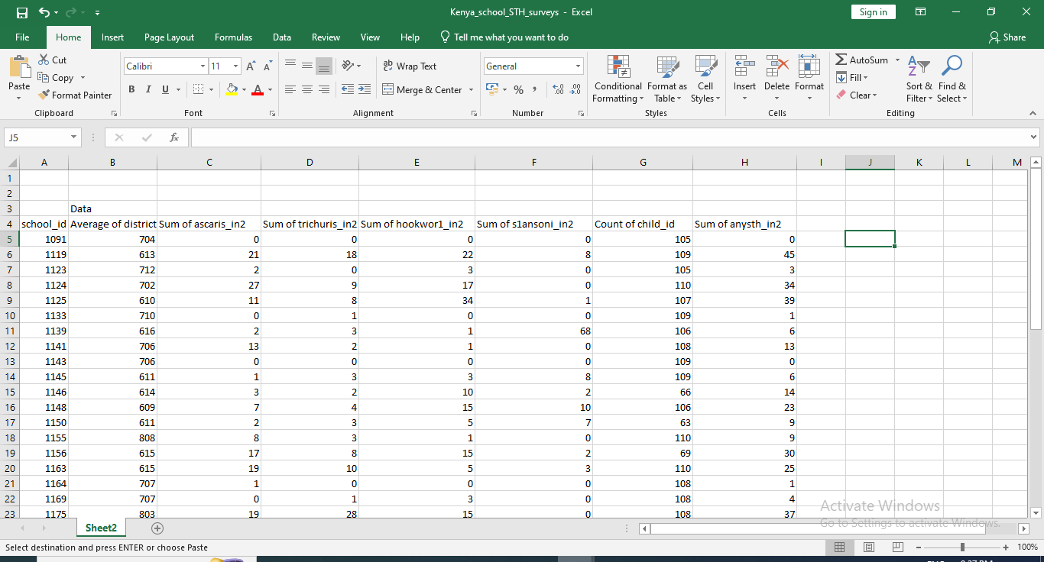

Save this new data table as **Kenya_school_STH_surveys.xlsx**

Now we need to know the total count of infected children, that is, the prevalence of STH. So, w ecreate a new column:sth_previn which we are going to be dividing the number of infected children by the number of children and multiplying by hundred to obtain a value in percent (%). In the first cell under the heading type =F2/C2*100 (this assumes that your number of children is in row C and the number of infected children in row F; you will need to adjust the column label accordingly); then copy the formula to the other cells in the column.

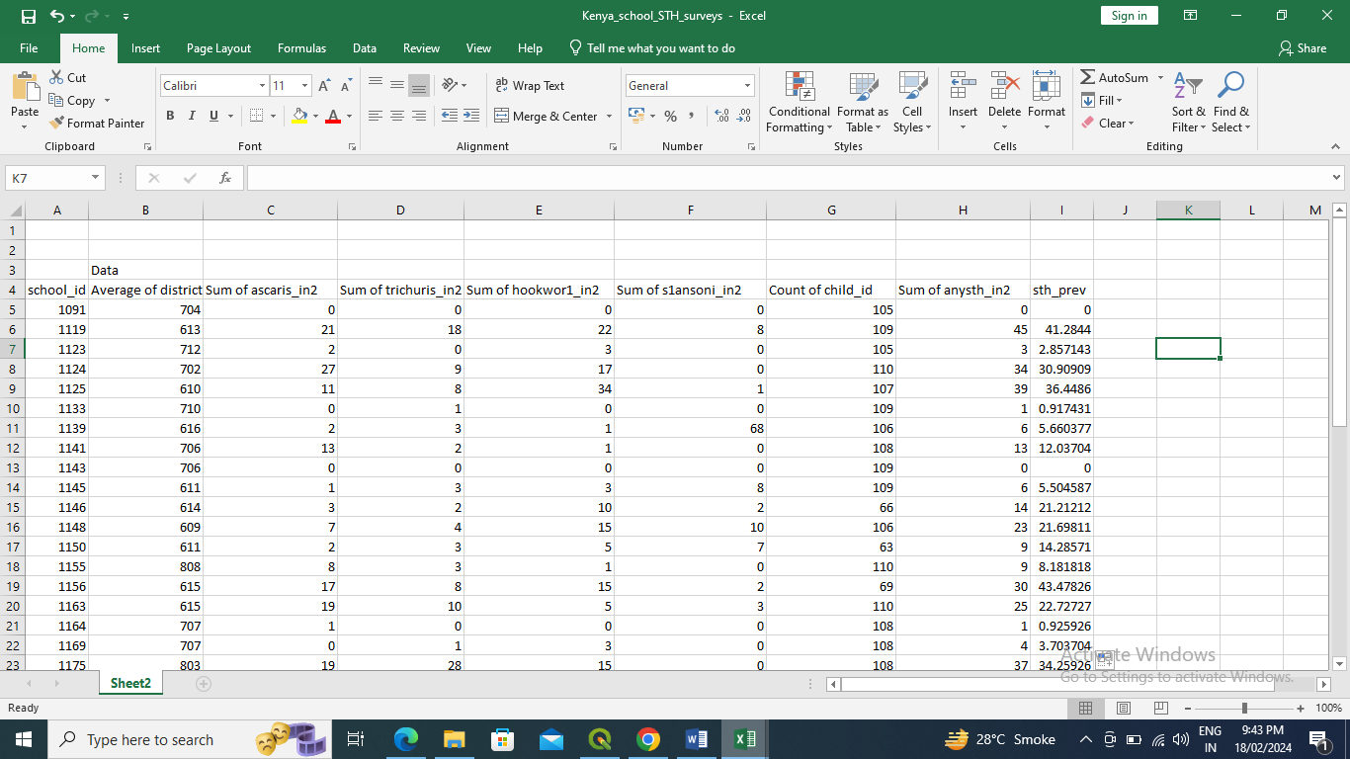

Additionally, you could calculate the 95% confidence interval (CI) of your prevalence. You will have to create a new column called “CIlow” (lower confidence limit) and “CIup”(upper confidence limit) You can calculate the limits by typing the formulas as follows and then copying to the other cells: For CIlow: =I2 - (1.96*(SQRT((I2*(100-I2)/C2)))) For CIup: =I2 + (1.96*(SQRT((I2*(100-I2)/C2)))) Assuming I2 as sth_prev and C2 as Count of child_id, adjust accordingly.

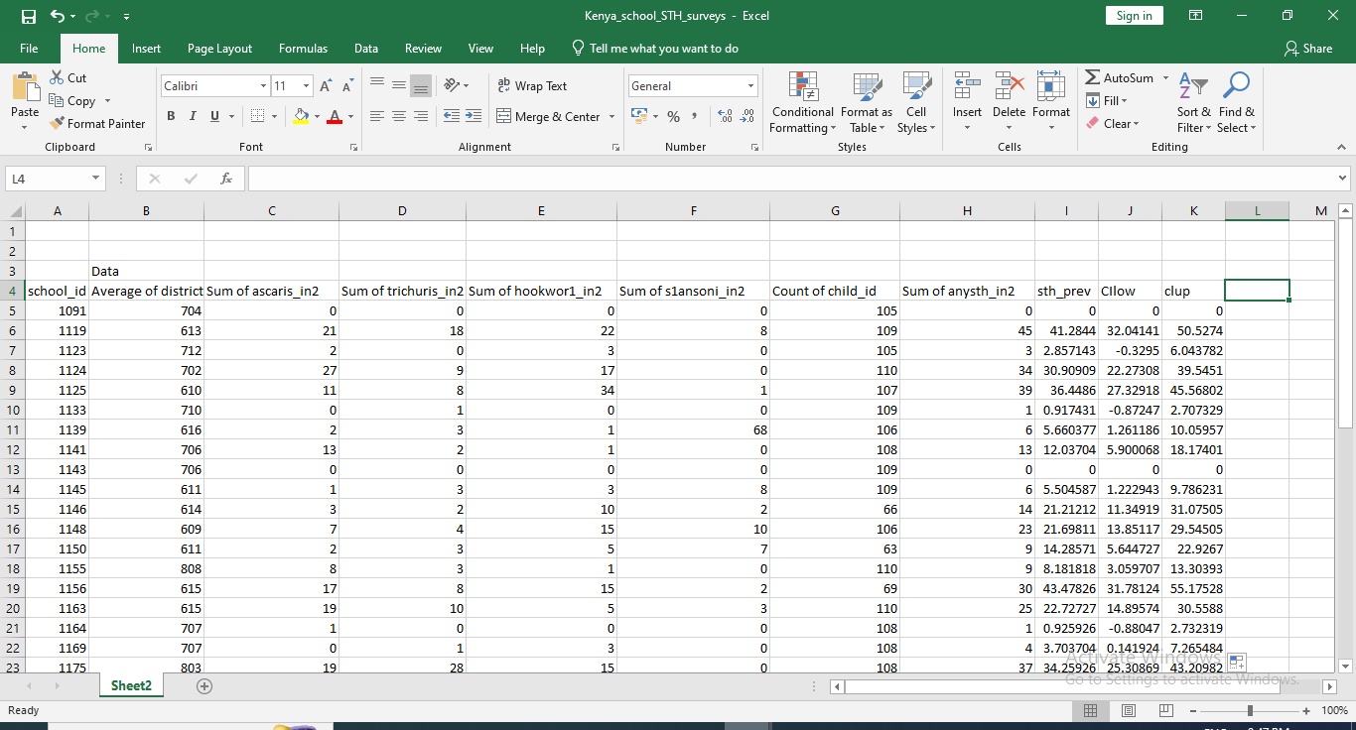

Step 16: Open a new QGIS project.

First, add **Kenya_school_location2.csv** to the project. Click on Add Delimited text layer in the menu, and browse to select the file.

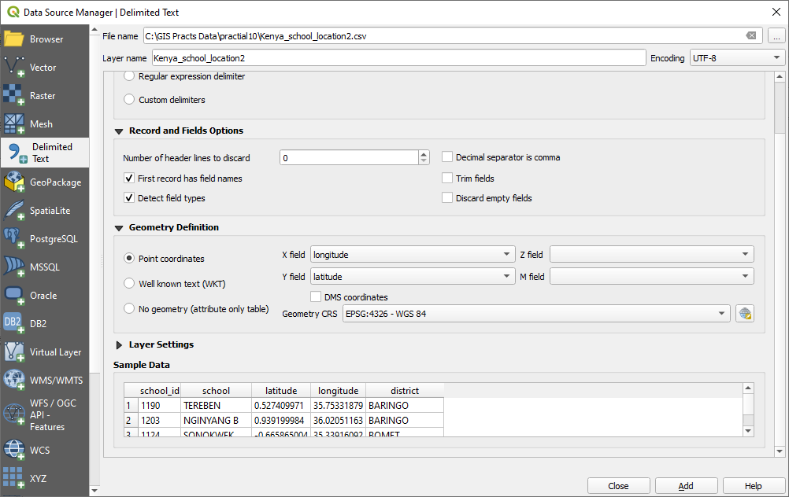

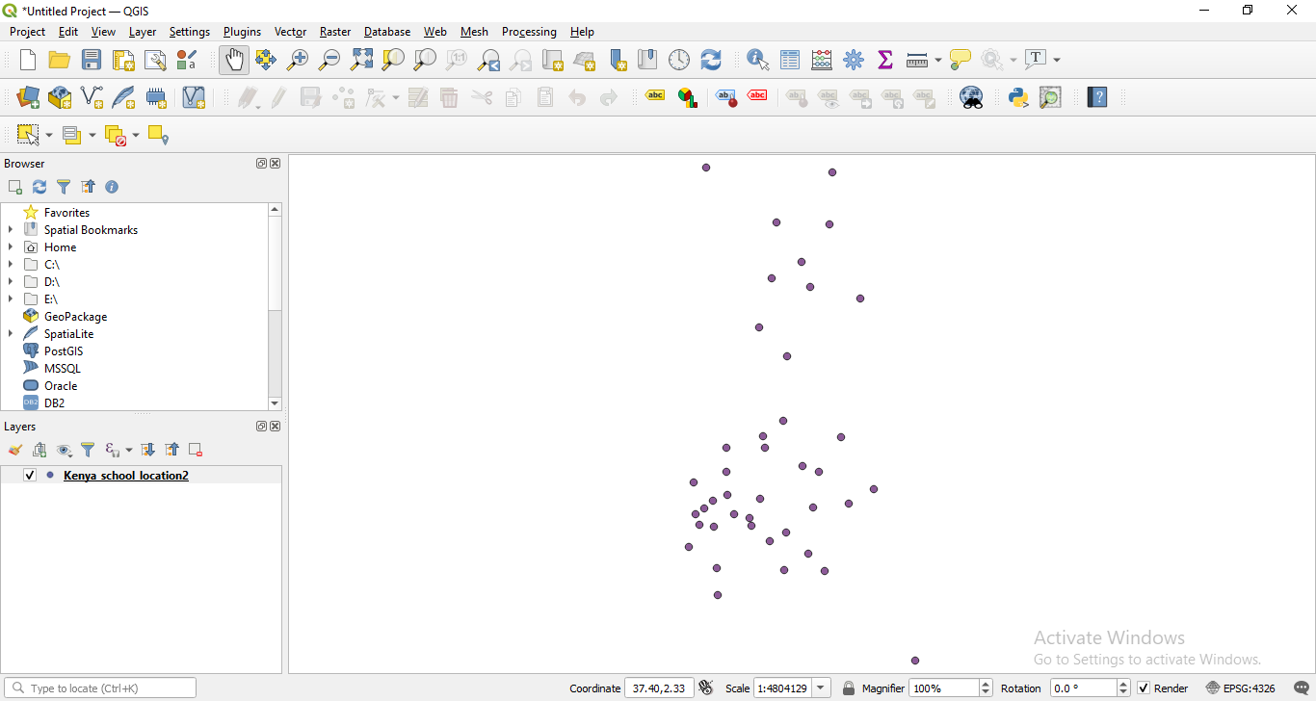

Step 17: Similarly, Add Vector Layer and add Kenya_ epidemiological_school.csv

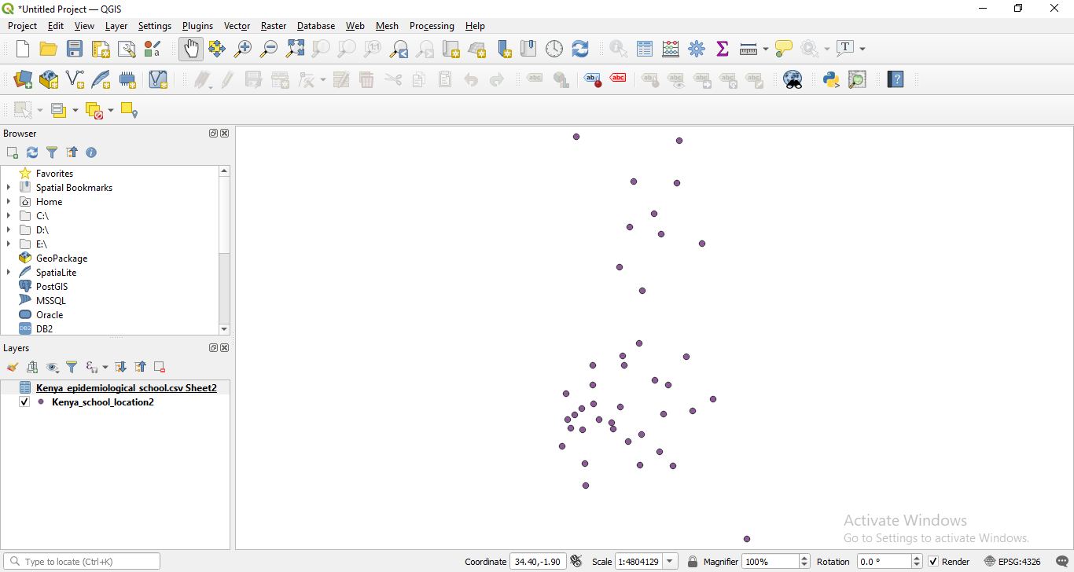

Now we’ll join the data. Right click on Kenya _school_location2 layer and click on Properties

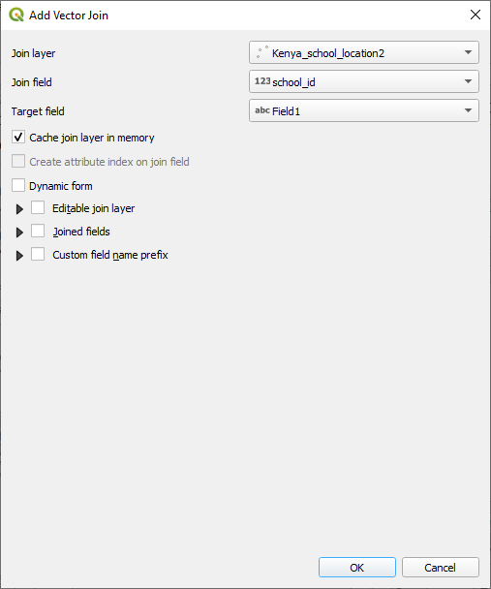

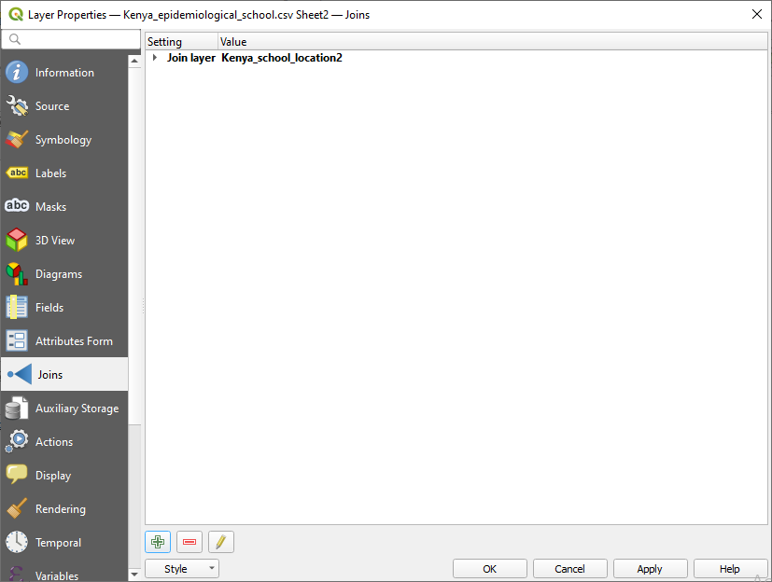

Right click on Kenya_epidemiological_school – open attribute table

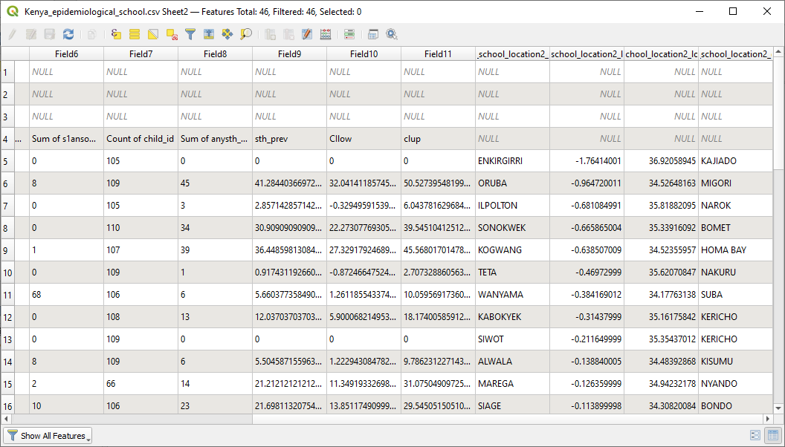

Step 18: Select all the layers, right-click on them and in Export select Save Features As.

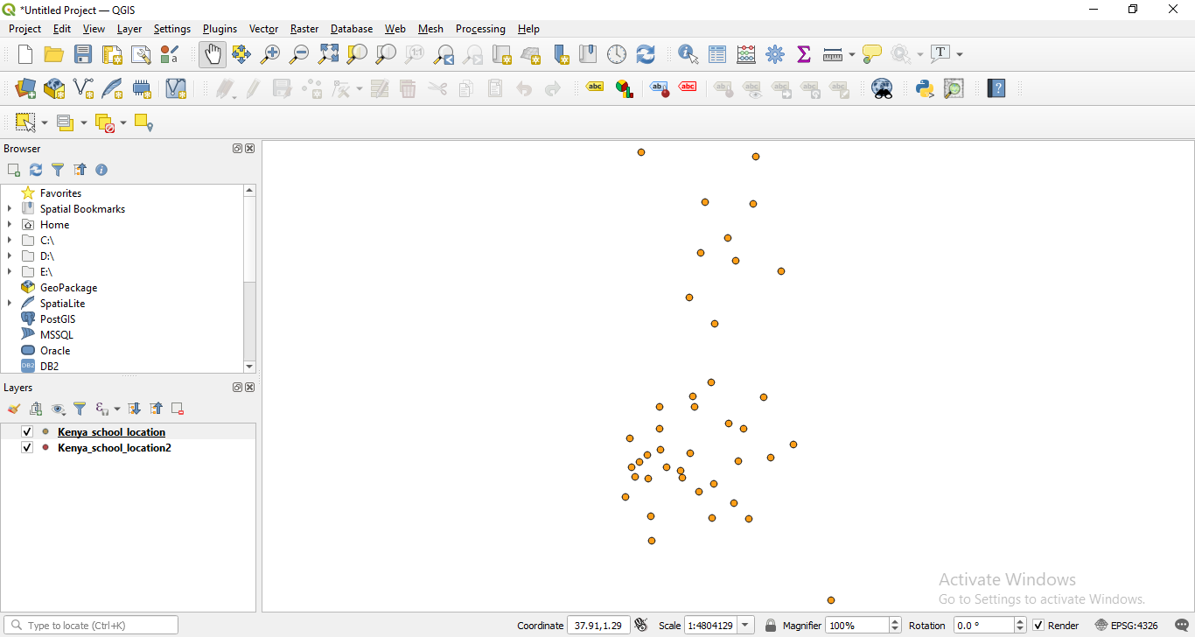

Similarly, Add Vector Layer and add Kenya_ epidemiological_school.csv

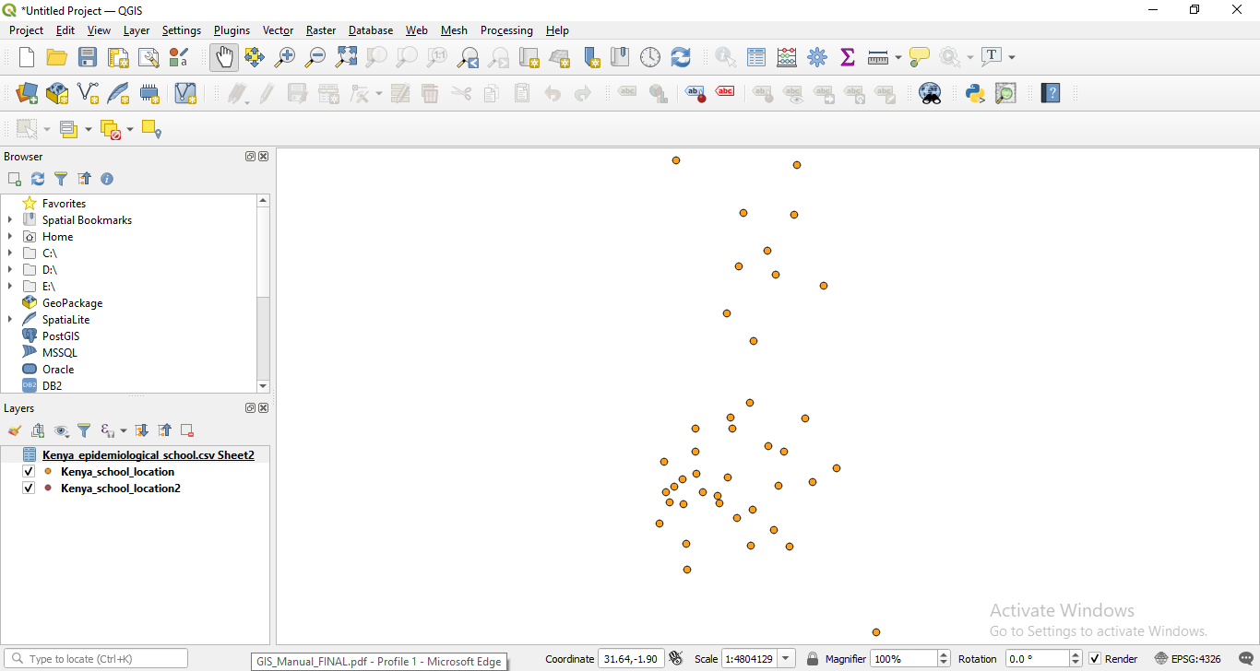

Now we’ll join the data. Right click on Kenya _epidemilogical_school layer and click on Properties

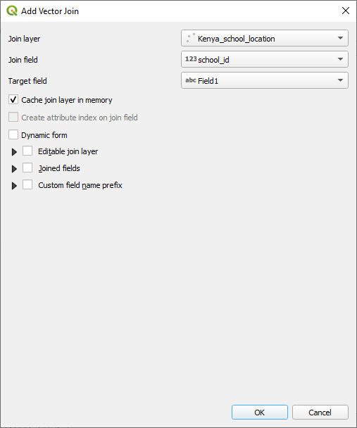

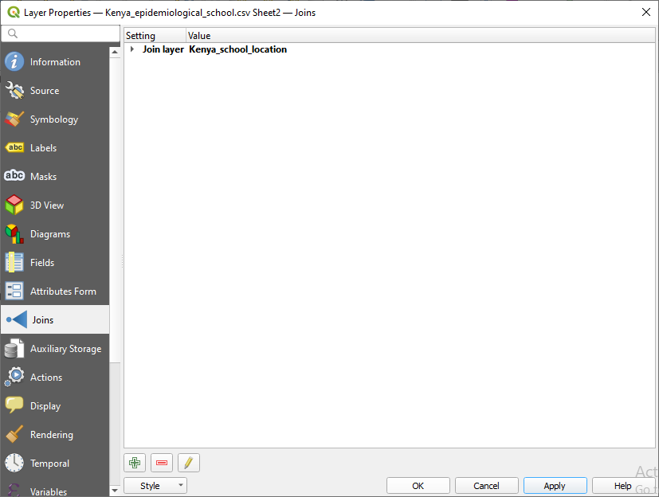

Right click on Kenya_epidimilogical_school layer and select Open Attribute Table.

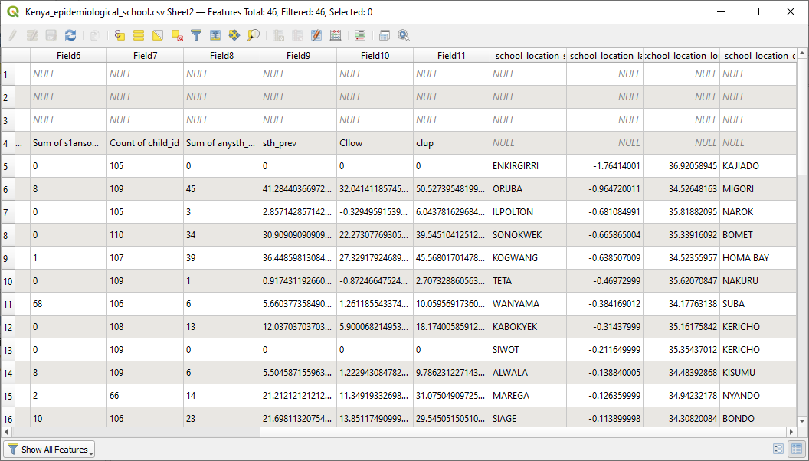

all the layers, right-click on them and in Export select Save Features As.

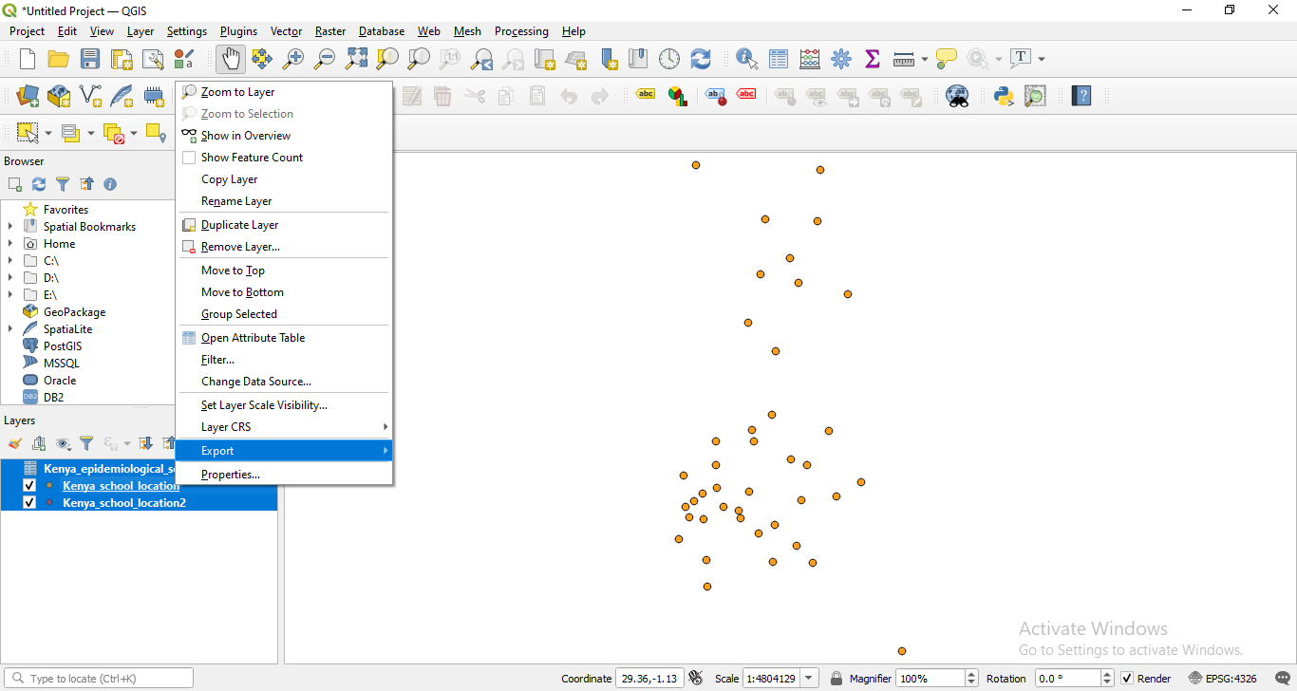

Select Format as ESRI Shapefile and File Name as: Kenya_school_epidata.shp

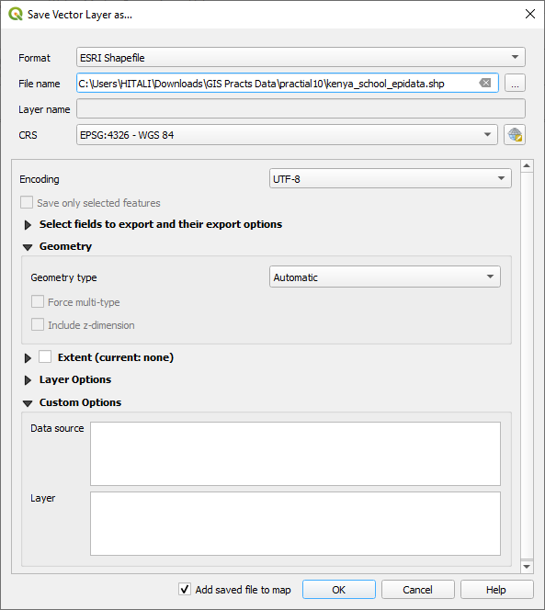

Output:

